The Mielke’s Ice Cutting Business on Lake Sarah

Herman and Cora Mielke purchased the Breezy Hill Resort (the property currently owned by Kimberly and Perry Buffie) in 1938, it had three cabins on the property at the time. Beginning in 1939 the Mielkes operated an ice harvesting business from their resort cutting tons and tons of ice on Lake Sarah until Art Mielke (Herman’s son) retired from ice making in 1974. Prior to 1945-46 when electricity came to the area, each resort and the dance hall had ice houses where they stored their ice until summer for use in their ice boxes and to cool their beverages. The Mielkes cut the ice to fill all of these icehouses. They also furnished ice for the Delano 4th of July celebration and the creameries in both Rockford and Delano. Whenever a wedding or party was to be held in the area, they would put the big blocks of ice into stock tanks to cool their beer and beverages. Art Mielke has videotape made in the early 60’s from old movies taken by Art's sister Irene. The video shows not only the ice cutting and storing process; it also shows the shoreline and many of the buildings that were located on their property. The Mielke's barn can be seen in the background of the photo - below right. Art was kind enough to lend us the video, which has now been converted to digital. The video does not have an audio track, although Art hopes to add narration to the video soon. After converting the video I spoke with Art who was quick to point out the movie made the process look much simpler that it truly was!
They started cutting when the ice was 16 inches thick. The ice usually got to be about 30 inches thick by the time they finished cutting. A record year was 38 inches! At that thickness, each block weighed as much as 400 pounds. Ice could only be cut when the air temperature was above 10 degrees F. When the air was too cold, the ice blocks became fragile and were prone to chipping at the corners or cracking. Herman Mielke made the ice grippers that the men wore on their boots while cutting the ice. Art recalls that great care was taken to keep the process safe. No one ever fell into the icy water. There was one close call when Art’s dad stepped on a block of ice that he thought was part of a long tier that was not broken up yet. Fortunately, Art was close behind him and grabbed his jacket, pulling him back to safety before even his foot got wet!
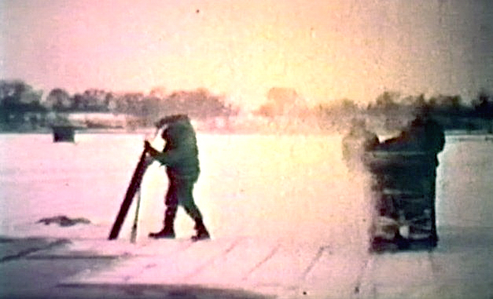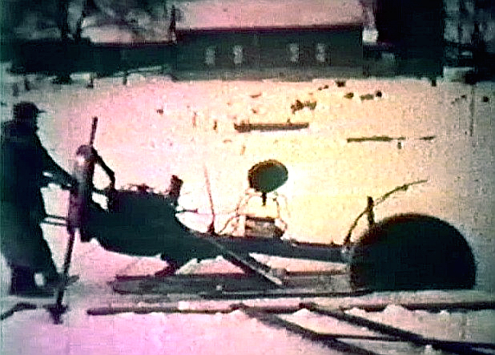
The ice was cleared and scratched with a chisel using a large wooden square to mark a large grid. Herman Mielke made the power saw pictured above from the engine, drive train and transmission of a model A Ford with a 30” saw blade attached which he balanced on a cradle (like a teeter-totter on a skid). The saw was typically operated at ¾ throttle using the model A’s 2nd gear. Art still has a 40” blade from the saw for use when the ice was thicker. Herman and Art’s uncle, Herbert Becker, typically operated the saw; both are shown operating the saw together on the video and in the images above. The saw cuts were made in both directions such that there was 2” of uncut ice at the bottom. This was done for safety and to keep the water from getting into the cuts. The ends of each tier were cut by hand as they were broke out using the long hand saw as Art is shown doing in the picture above (left).
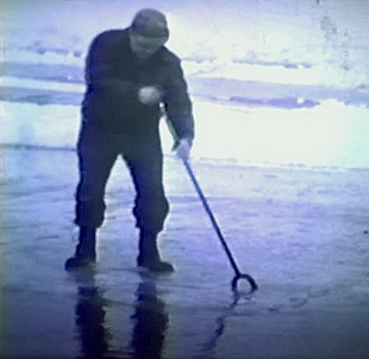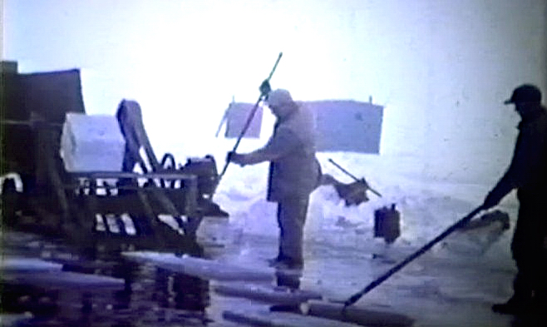
When it was time to load the ice blocks (called kegs), a spud chisel was used to break off a long tier (row) of the nearly cut ice kegs. The row of kegs was then floated towards a conveyor that was positioned at the edge of the cutting area. The blocks were then broken apart and the individual kegs were then guided onto the conveyor and loaded onto the truck. It took only a slight hit with the spud chisel to break the thin layer of ice that still held the individual blocks together. The truck could haul 22 ice kegs per trip. The conveyor, also made by Herman Mielke, was constructed of wood and angle iron and positioned 8” or so below the ice sheet. A wide belt over a wooden pulley powered by a “one lunger” engine drove the conveyor. The images below show Art Mielke sliding the kegs onto the truck using ice tongs. In the background of the photo on the right (above) you can see a couple of fish houses that the Mielke’s used for fishing sunfish when they weren’t cutting ice.
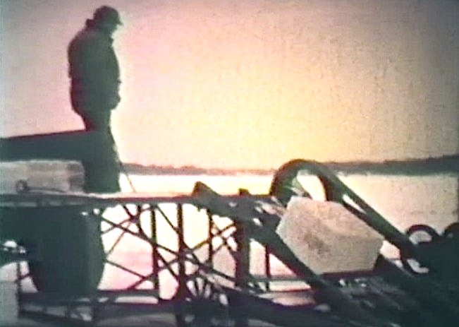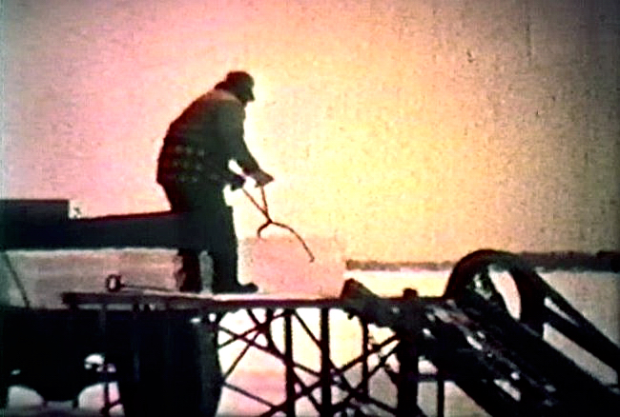
The ice was stacked into each icehouse using another conveyer system. The photos on the next page show Art Mielke (left image) feeding blocks off the truck onto the conveyor to his brother-in-law Ray Thompson (right image). Ray was pushing the kegs into the icehouse, probably forming the third or fourth layer of ice blocks. Each keg was trimmed using a chisel or shaver until it was square. The blocks had to fit tightly together leaving no air spaces between them to keep them from melting. It took two and a half truckloads to form one layer of kegs in the Mielke’s icehouse. After each layer was set, the top of the new layer was shaved until all the kegs were the same height in preparation for the next layer. Depending upon ice thickness the icehouse would hold 5 – 6 layers or about 260 kegs on average. It would take a full day, or perhaps day and a half, to fill their icehouse. Eight inches of sawdust insulation was packed around the outside and on top of the ice blocks for insulation and protection from air. The sawdust came from the Greehling’s who owned a steam-powered sawmill located on County Road 92, just north of the horse facility currently operated by the Shriner’s.
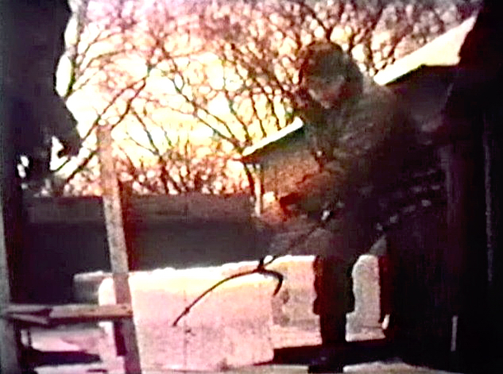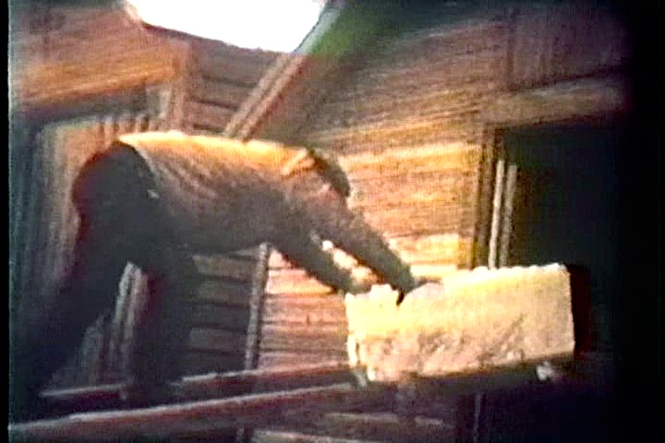
The photos used here were captured from the actual video. To view the entire 10-minute video visit www.lakesarah.com and use the streaming video link that can be found on the History page (this link works best with a high speed internet connection). Thank you to Art Mielke for continuing to share the memories and memorabilia from his family’s long history on Lake Sarah! Also, Thank you to Mark Paulson who was able to convert the old movie into digital format so this video and these images can be viewed and shared!

-Article by Brad Spencer with a lot of help from Art Mielke!

