**SHADY BEACH BELL STOLEN - A DISSAPPOINTING DAY FOR HISTORY BUFFS**

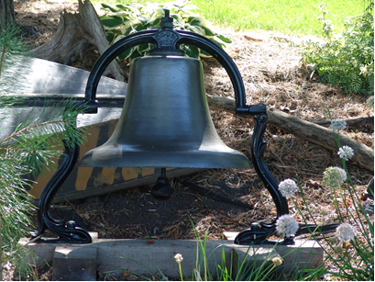

In late February 2016 a century+ old 26” Blymyer Norton cast steel school bell weighing nearly 200 lbs. was stolen from its home on the shore of Lake Sarah and was taken away by thieves over the lake ice.

**A $500 reward for information leading to the apprehension of the thieves and recovery of the bell is offered by the Spencer family. Please contact West Hennepin Public Safety at 763-479-0500 if you know of the whereabouts of this important piece of local history.**

Carl Scott Zimmerman, Campanologist, identifies the foundry as the Blymyer Norton & Company, Cincinnati, Ohio (which later became the Cincinnati Bell Foundry Co.). A detailed history of this company is not yet known except that it was organized under the corporate name of Blymyer, Norton and Co. on December 15, 1866. Due to successive name changes our best guess is this bell which is clearly marked B.N. & Co, CIN O on the yoke was founded in the period 1866-1890 making it well over 125 years old. The bell is in excellent condition, measuring 26” across the mouth and is cast of steel. This bell was probably originally purchased for a local schoolhouse, one possibility is the Wagner School which maps show was originally located just north of county road 11 and subsequently moved to the southwest corner of county road 11 and Independence Rd. due to flooding. Earl Taylor, curator of the Independence History Museum, says the Wagner School was in existence between 1880-1921 and was closed largely due to the opening of the catholic school in Loretto in 1920. The catholic school today still has its bell, a Blymyer 24” with a rope wheel. Two other schools, Evergreen Grove and Lyndale School, which were in existence at that time were eliminated as a possible source as they still had their bells many years later. The Evergreen bell remains on display by the current residents today. The Wagner School appears to be the only local school which fits our timeline, but hard evidence linking the bell to that origin has yet to be discovered.

Florence Jacobs (Snodgrass) recalled in an interview, the bell being used to call hotel guests to dinner while she and her sisters worked for Mrs. Anderson at the Anderson’s Inn before the Depression in the 1920’s. Richard Klaers also remembered the bell being used to call people off the lake in the event of oncoming bad weather. Following the sale of the Anderson’s Inn (by now named Shady Beach Inn) to the LaMotte’s in the 1930’s, the bell was primarily rung by Mrs. LaMotte to call her husband up from the resort buildings below or to announce that dinner was ready. At the Shady Beach Inn during that period, as recalled by Eileen Klaers (Grotz), the bell was mounted atop a wooden tower roughly 8’ tall that was located 25’ or so from the lake facing side of the Inn near the top of the hill and was rung by means of a rope/strap tied to the clapper. Later, photos show the bell mounted to a tree stump in the 1950’s. On one occasion, as Susan LaMotte was ringing the bell, it fell from the tower and reportedly broke her foot. The bell was never to hang from the tower again. Susan LaMotte walked with a cane due to the injury until her passing 2 years later. LaMotte’s sold the resort in the 1950’s to Milton (Mac) Makousky. Mac sold the bell to Marvin Johnston in about 1956. Marvin owned it until his passing in June of 1992. Marvin’s son Dennis then inherited the bell. Denny and his wife Jackie displayed it in their beautiful front garden for many years until they put their home up for sale in 2006. Thus it was sold to the Spencer family. The Spencer’s wished to retain this unique piece of local history in the Shady Beach area and had since repaired the support, cleaned and repainted the bell and installed it in their hillside overlooking the lake. Sadly it will never ring over lake Sarah again.

It is a distressing and helpless feeling of personal violation that someone would remove something like this for whatever personal reason they may have had. It is a sad commentary on the general untrustworthiness of some of our fellow citizens. To the thieves we would say only may God be your ultimate judge.