OLD POSTCARDS CAN OFFER A RARE GLIMPSE OF OUR PAST!

Most of us have seen this often circulated old advertising post card below of the famous Shady Beach Inn (aka. Anderson’s Inn) dated around 1926. Note the old Ford in the driveway on the left edge of the photo.

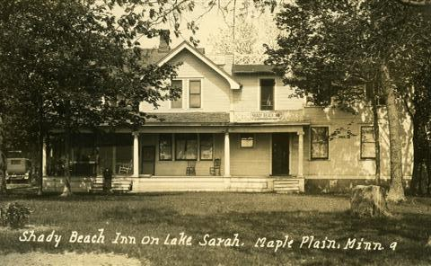
The view in every photo or postcard of this historic Inn that I’ve seen is of the west facing (street side). I have always wondered what the lake side of this structure looked like in its glory days!

The building (formerly Tom & Jacquie Emmer’s home) has long since lost its second story and successive owners have dramatically remodeled the building’s exterior over these many years.

The pictures below show the greatly reduced structure in the 70’s which had been by then converted to a single family residence. Photos show the street view (left image) and the lake side of the building after it was purchased from the Erickson family by Darrell & Roberta Schultz in 1972 (the Ericksons bought the house from Dorothy Makowski). Note the building is missing the second floor and you can see the footings on the lake side for an expansion. The garage was added a few years later.

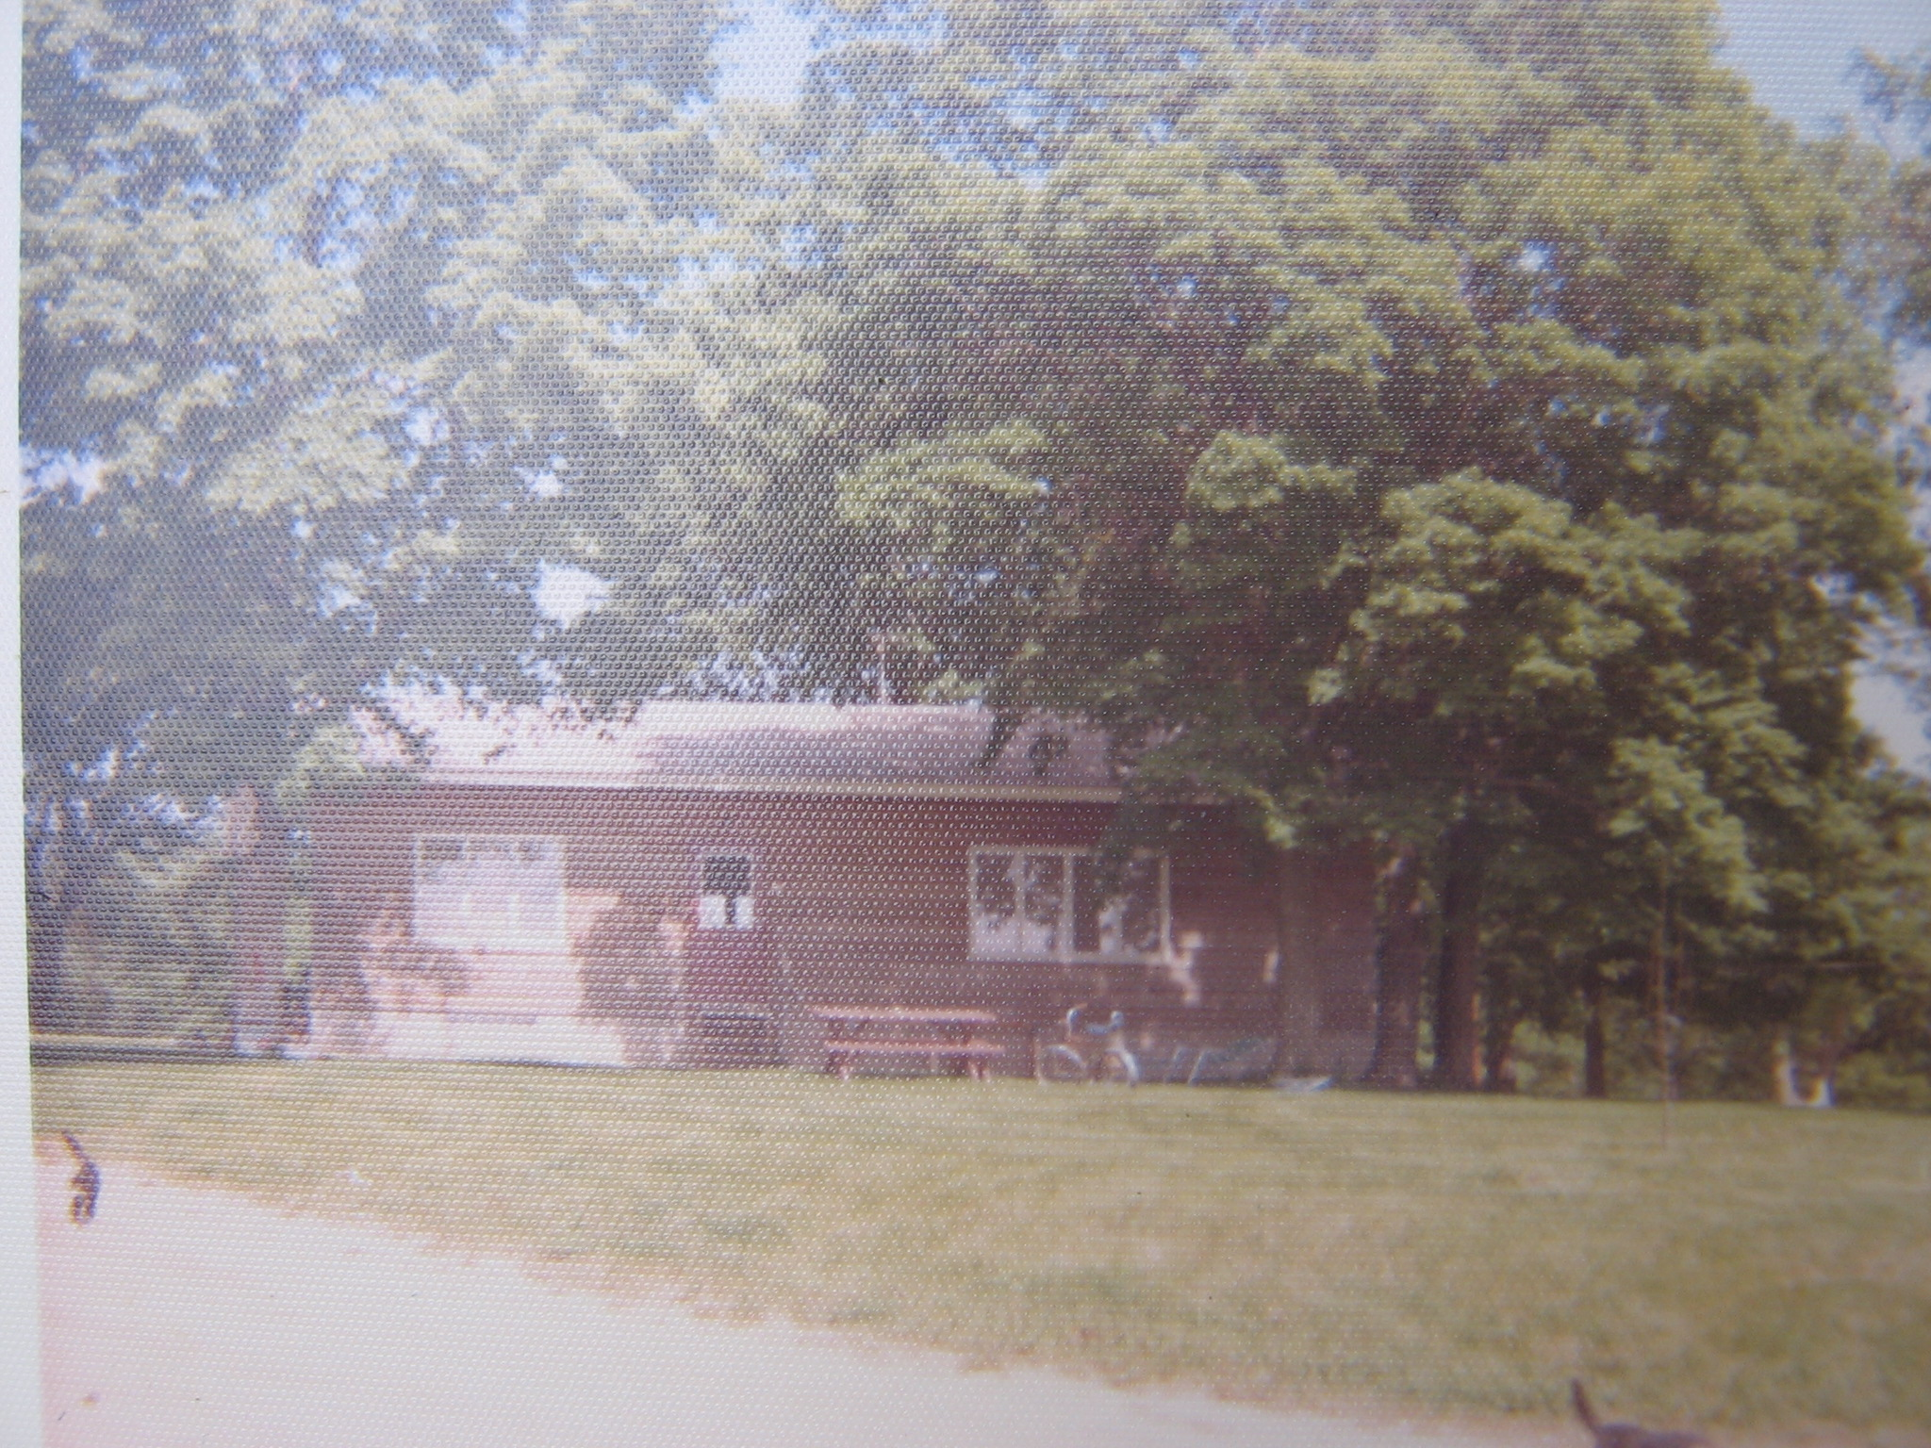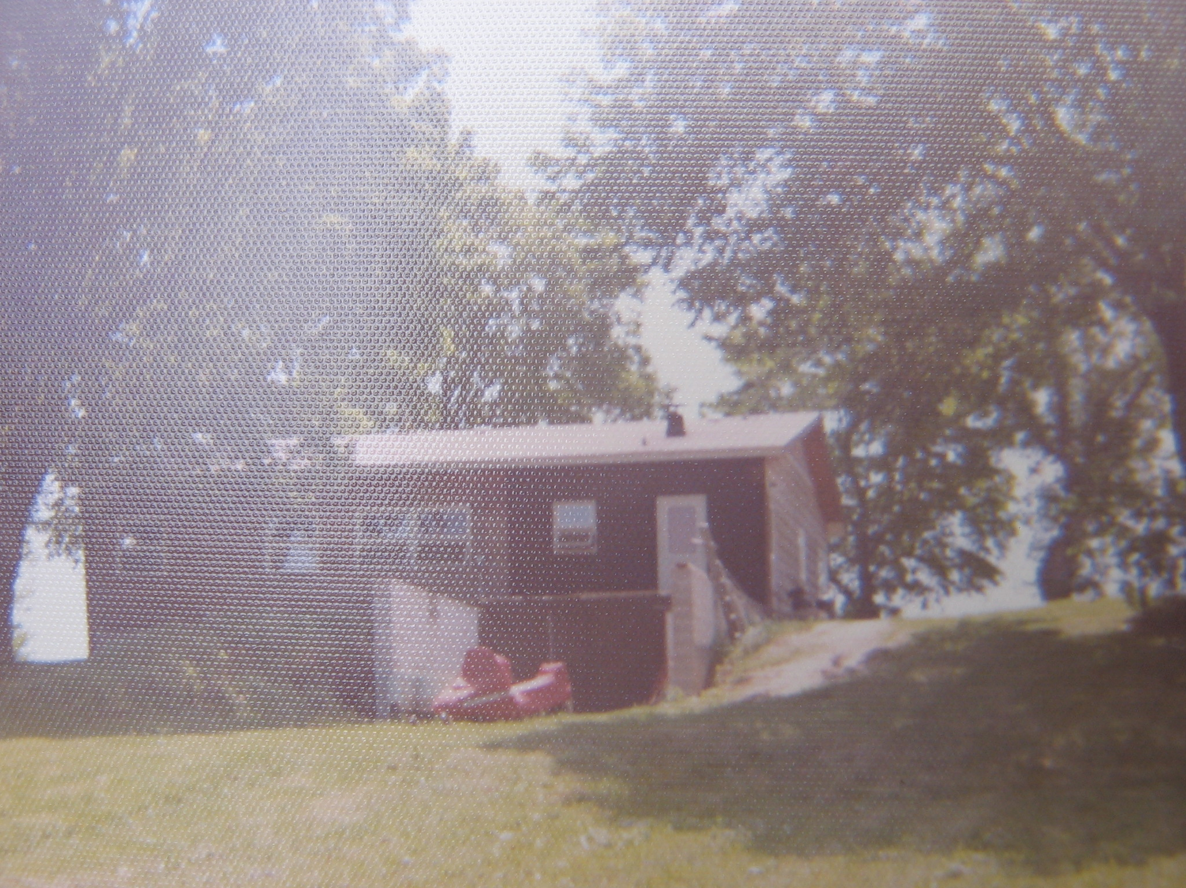

After months of looking for pictures I stumbled across the postcard below which shows the only view I’ve encountered of the east facing (lake side) of the Anderson’s Inn from the period prior to the Great Depression.

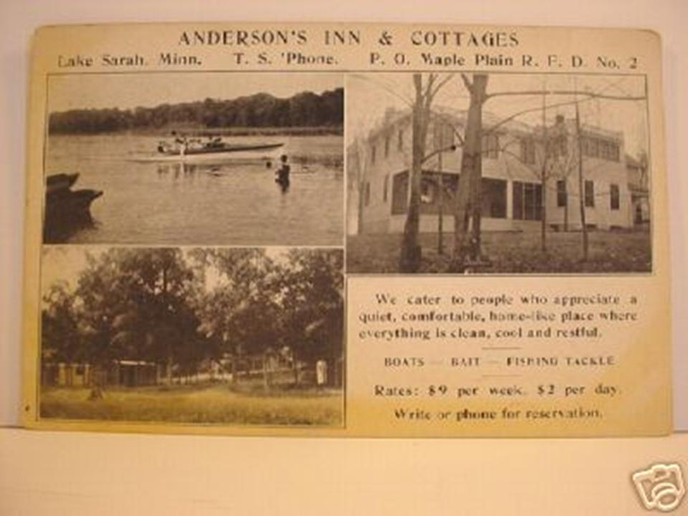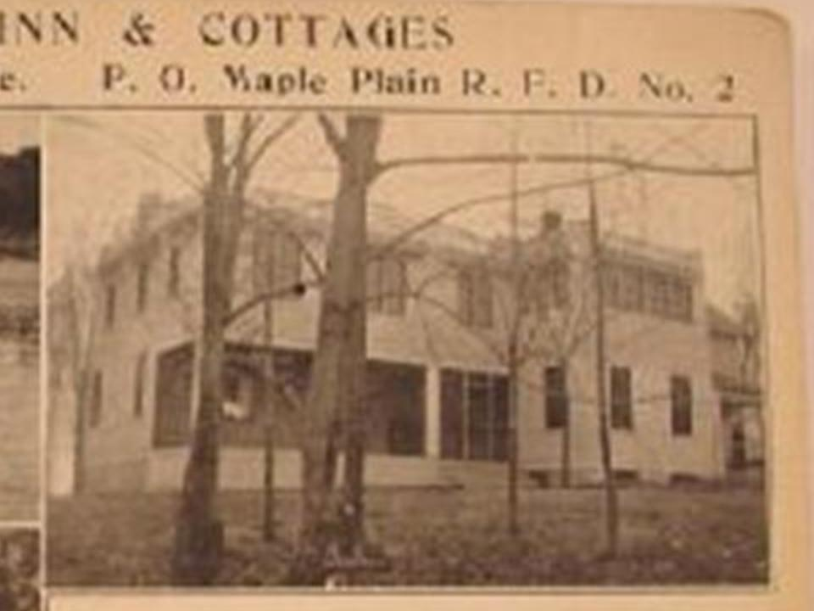
By enlarging the portion of the image on the cards right side we now know what the lake facing of the old Inn was like in the 1920s. Admittedly, not at all what I had expected!

Thank you to Darrell and Roberta Schultz for sharing some of their photos and stories with me! If anyone has old postcards, photos, or stories from Lake Sarah’s resort and dance hall heydays that they would be willing to share please contact Brad Spencer 763.479.3525 or email b.spencer@lakesarah.com.

