Was the Levi Bowen Camp and the Hillcrest Resort the same property at different times in History? by Dr. Perry Buffie
I am pretty sure that Hillcrest resort and the Levi Bowen camp are one and the same. I have an old map (1880) of the property owners of the time, covering most of western Hennepin and eastern Wright county. Comparing that map (with the Bowen place on it) and the map from Kathy Hahn of resorts in the 40's (showing Hillcrest), they are in the same place. That property is the one just to the east of the property currently owned by the Buffie family, so I am somewhat familiar with it. Take a look at the cabins in the old pictures below, you will see how similar they are, maybe even depicting some of the same cabins in their pictures.
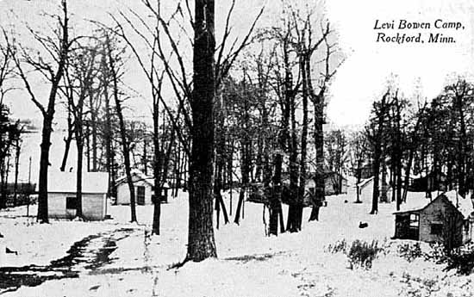
Levi Bowen Camp - ca. 1900 - photo used with permission Minnesota Historical Society
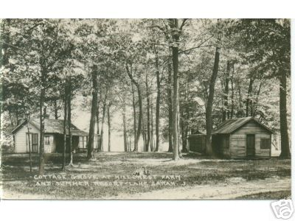
Cottage Grove at Hillcrest Farm and Summer Resort postcard - postmarked 1922

Photos used by permission, unauthorized reproduction or use is prohibited

