Lake Sarah History: Art Mielke Watches Resort Community Flourish, Then Die
By Dolores Ullstrom
to fly fish. Their friendship remained strong right up until Jack died.

Art Mielke lived on the western end of Lake Sarah for 38 years. His parents and later he and his wife owned Breezy Hill resort. The farm where the resort was located was split up; the house and remaining 20 acres were sold in 1974. Kimberly and Perry Buffie, current owners, purchased the property on North Shore Drive in 1997.

In high school Art use to trap a lot of muskrats around the Lake. He took them to Minneapolis to sell. He used the money to help purchase a new 1956 Ford.
Art remembers Frederick's Resort. It closed when he was 15 years old (1953). He also remembers that there was a Bud and Max's Resort located between Frederick's and Hillcrest Resort on what is now North Shore Drive. There was a round building near the railroad tracks (6475 North Shore Dr) on Bud and Max's land. Pop and beer were sold from this building. The Bowens owned Hillcrest Resort. They had lots of cabins.
Elm Beach Resort
The Sandlass property, on the south side of Sarah, was the site of Elm Beach Resort. When Art was very young, Elm Beach was owned by an elderly bachelor named Sam (last name sounds like Hinchmen). The resort consisted of one small building. Sam's cot was in the bar area. A kerosene space heater was used to heat the building. In summer Sam rented out boats. In the winter the building was a 3.2 beer tavern with a cigarette license. Elm Beach had an on-sale license, while Breezy Hill had an off-sale only license.
Art was about 7 years old when the Eppels, Bud and Bernice, bought Elm Beach from Sam. They added a house onto the bar for their living quarters. The Eppels did not have a food license, and serving game fish was illegal, but many fish fries were held at Elm Beach. Folks came to socialize and to buy beer. About 10 p.m. on Friday night, the fish caught in Lake Sarah were fried, and patrons helped themselves. When they were lucky, a big pot of turtle soup was also served.

The Lake Sarah souvenir map, copyrighted in 1946, (printed in the October, 1998 Mouth of Lake Sarah newsletter) was paid for by resort owners. It does not show Bud and Max's place. The Breezy Hills ad, located to the right of the map but not visible in our newsletter reproduction, shows Art's mother, Cora. She is holding a small dog on her lap. Art says that folks used to tease his mother because the dog"s ears make it look like she is wearing a bow tie.

Ice Making Business
The Mielkes cut ice on Lake Sarah for many years. They furnished ice for all the resorts on the lake. They have a video tape, made from old movies taken by Art's sister, Irene, that not only shows how the ice cutting and storing process, but also shows the shore line and many of the buildings that were located on the property.

Herman Mielke, Art's dad, made the ice grippers that the men wore on their boots doing ice harvesting. Art recalls that great care was made to keep the process safe. No one ever fell into the icy water.
With a long saw they manually cut almost all the way through the ice making rows after row of blocks. Later, when it was time to move a single block, a chisel broke through the thin layer of ice that held the block to the others. They started cutting when the ice was 16 inches thick. The ice usually got to be about 30 inches thick by the time they finished cutting. A record year was 38 inches. Each block weighted about 400 pounds. The ice was stacked in an ice house using a conveyer system. Eight inches of sawdust insulation was packed around the ice blocks.

On the video is a man named Jack. Jack first came to Breezy Hill with his new wife on their honeymoon when Art was 5 years old. After that they came out to the cabin every summer for two weeks. Jack taught Art how to shoot a 22 riffle. The two of them use to go duck and pheasant hunting together. When Art was nine years old, Jack taught him how

Freeway construction provides housing
Soon after they were married, Art and Judy Mielke moved their first house onto Breezy Hill property. The freeway system was being built and many homes needed to be moved to make way for the freeway. The Mielke's home was moved from near the site of the 394-494 interchange. Robert and Jane Lynch, 6325 Lake Sarah Hts Dr, also moved in their first home. That home is currently owned by Seth Victorsen. Maurice McKinley, who bought Breezy Hill from the Mielkes in 1974, was in the business of building fences along the newly constructed freeways. He used many of the resort's buildings to store his materials.

The end of an era
Art remembers a couple that came to Breezy Hill every year and rented a cabin for one month. They lived by the fairgrounds in St. Paul. It took one and a half hours to get from their home to Breezy Hill. Neither cars nor roads were as dependable as they are today. Art grew up with their children. When their youngest child was out of high school, about 1950, cabin rental costs started to go up, and the couple decided it was time for them to buy their own cabin on Forest Lake.

Growing prosperity gave many people the money they needed to buy their own boat and a small cabin. Having a cabin up north became the latest fashion. The mood seemed to be that a vacation wasn't a vacation if you didn't drive 50 or 100 miles to get there. The family owned resort business around the Twin Cities faded quickly. It got to the point where one could no longer make a living running a small resort like Breezy Hill. Development was quickly occurring. Taxes went from $500 to $2,000. New restrictions and regulations meant that life as he had known it was changing. People no longer wanted to see his cows in the lake. Fishing and trapping were not as good as they had been. Art and Judy decided to sell. They used the money from the sale of

Article from the April 2002 Mouth of Lake Sarah newsletter
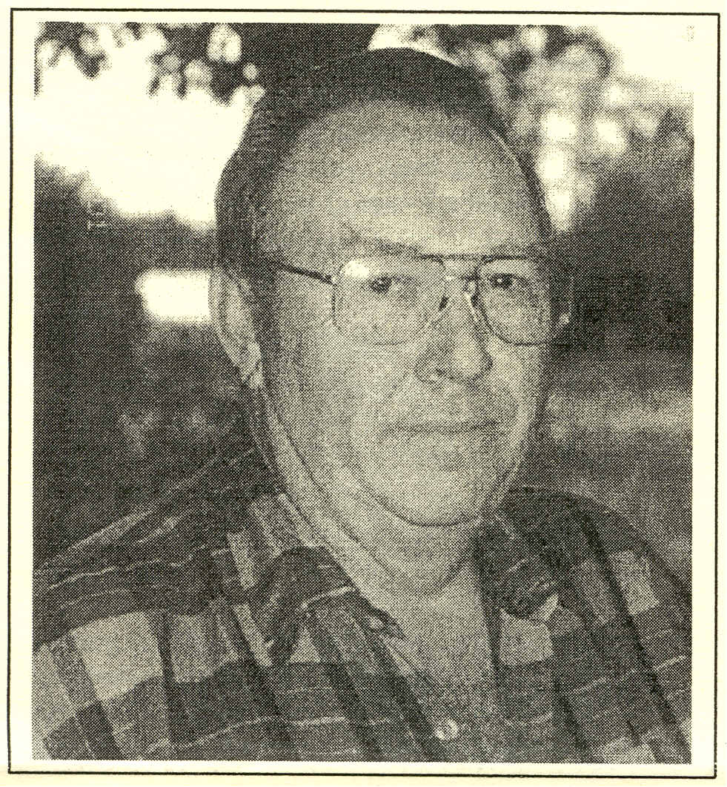
Breezy Hill to buy a dairy farm near Chippewa Falls, Wisconsin. They now raise beef cattle.
History cannot be turned back, and maybe it shouldn't be. We have lost and we have gained in the process of change.
Thanks, Art, for sharing your stories with us.
Photo: Art Mielke, former owner of Breezy Hill Resort

