Lake Sarah History: The Bukowski Farm
By Dolores Ullstrom

My house sits on land once owned by Lambert Bukowski and his wife Helen (nee Van Lith). The Abstract of Title for the property states that the land was first plotted in 1856. In 1864 the United States of America turned over the ownership to Jotham S. Malbon. There were several owners from then until 1883, when Peter Bukowski became owner. Peter is Lambert's grandfather. In 1886 Peter and his wife deeded over a 100 foot strip of land to the railroad. In 1890, Lambert's dad, John, became owner. Lambert took possession in 1944.

Helen & Lambert 50th Wedding Anniversary 1992
Helen now lives in the ParkView Health Care Center in Buffalo.

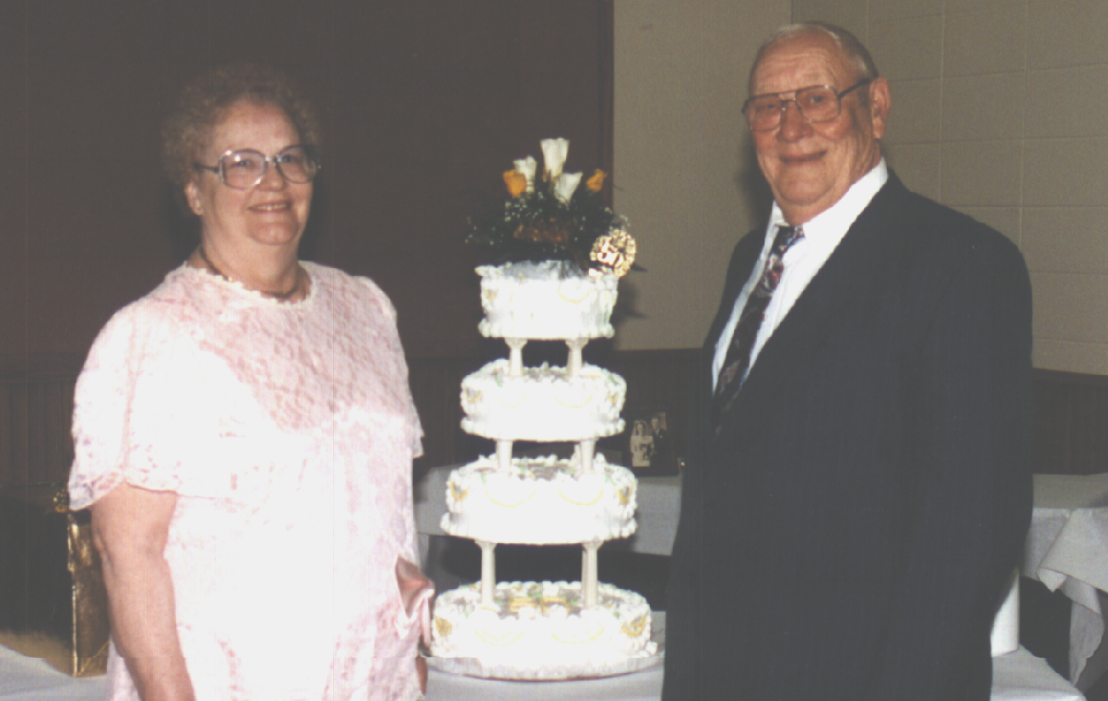

Lambert recalls that until 1939 every farmer who had land on Lake Sarah had boats to rent. There were approximately 150 boats to rent on the Lake. By five o'clock Sunday morning, all the boats were rented out by fishermen.

Lambert loves to talk about Lake Sarah History. He still lives in the house in which he was born July 9, 1913. His memory for names and dates is nothing short of phenomenal. His house is located on Hwy 55 just east of Lake Sarah Heights Drive. The Bukowski property was 40 acres in Greenfield and 40 acres in Independence, and included an area from Knapton's current raspberry patch to the Rokala Tree Farm. Before Hwy 55 was moved to its present location in 1942, the road that ran between the Bukowski house and barn was called Lake Sarah Road. Hwy 55 ran further north and in serpentine fashion wound its way east and west. As Lambert recalls, it was the automobile that forced road improvements to take place. It was not until 1925 when cars first became widely available, replacing horse-drawn sleighs, that roads in the area were open for car traffic during the winter months.

Lambert's father's cousin, who was a carpenter by trade, built two cabins on the farm and called the area Willow Beach Resort. A few years later, about 1923, when Lambert was 10 years old, his father took over running Willow Beach Resort. One of the cabins was located on the site of Carol and Randy Florek's home. The other cabin was also on the Florek property, but sat a ways down the hill. A road ran from Lake Sarah Road to the resort. Lambert says that if you look closely, you can see where the old road used to run.

The Resort had a picnic area with tables, tenting sites, a small store open on busy weekends, and 17 boats for rent in addition to the two cabins. Fishing boats at the time were heavy, wooden structures that were very difficult to keep from leaking. Every year before they were put into the water, Lambert had to fix and paint each boat. The boats were then left in the water to keep them watertight. Without drain plugs, bailing out the boat was a constant necessity. Manpower supplied the energy to row the boats, with outboard motors not yet in common use.

Occasionally the cabins were rented by the season, but mostly they were rented by the week or weekend. They did not have electricity or running water. Drinking water was carried from the farm to the cabins. An icehouse on the property held ice cut from the Lake and supplied ice for the store to keep pop and beer cold. One cabin had a porch, one bedroom, and a good size kitchen. The other had a porch and one large room with a cook stove and two double beds.

East of the Bukowski farm was a much larger resort called Klaers' Resort, located on the Theodore Klaers farm (later purchased by Beamish). The Boy Scouts used that resort every summer. Elsewhere on the Lake, Lambert recalls the depot located near Maple Beach (near the old public landing on North Shore Drive) and the hotel across the road and west about a quarter mile, where travelers used to stay. The hotel was torn down many years ago. Some of the train travelers took a large boat that held about 15 people across the lake to the Shady Beach Inn. Lambert smiles when he tells the story of riding the train from the Rockford depot (on the site presently occupied by the DiversiFoam Products) to the Lake Sarah depot.

One winter a dance hall built by the Begins was moved from the Mielke Resort on the west end of the Lake, across the ice to Maple Beach, near the depot. The dance hall later burned. The Mitchells then built a new dance hall on their farm.

In 1937 when he was ready to get out of the resort business, Lambert moved one of the cabins closer to his house and used it as a chicken coop. The other was torn down for lumber. He gave his boats to another farmer/resort owner.

Lambert began to develop his land that had lake access in the early 1960s. He built a road across the railroad tracks on the west side of his property in order to gain access to he lots he was developing. The access was eventually closed down by the railroad. The cabin owners along Lake Sarah Heights Drive in Greenfield were unhappy that development was occurring south of them on the Bukowski property. They would not allow their private road to be used. Lambert purchased a strip of land (1 acre) from Linfors and built a road along side the private road (east of the current Lake Sarah Heights Drive). He was then able to sell his lakeshore lots. Martha and Stan Godzala (now the Williams/Green property) bought the first lot.

Lambert says he does not regret the development that has taken place, but he is happy that his house sits by itself away from neighbors. He gets around his 10 acres on an electric golf cart. His daughter Susan lives with him and was very helpful in providing historical information. Lambert is still a farmer at heart, and at the end of our visit he gave me a ride in his cart and showed me his flourishing garden. Thanks, Lambert, for sharing history with us!

Photo: Lambert and sister Rose (Schumacher)

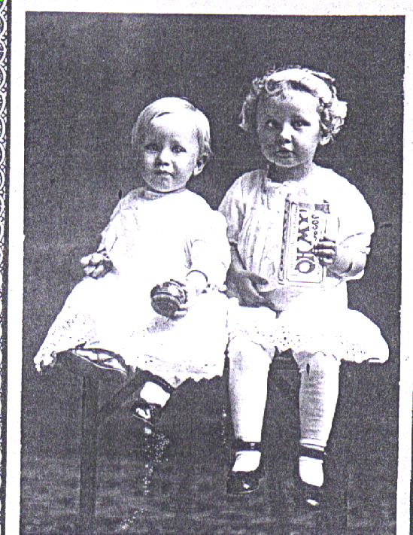

*this article from the Mouth of Lake Sarah News letter as originally published October 1998

