Lake Sarah History - Breezy Hill Resort Memories
By Dolores Ullstrom

A short time ago a gentleman named Art Mielke stood on our deck and looked wistfully at Lake Sarah. He got a bit nostalgic for the good old days, the days when he was young and his family owned Breezy Hill Resort. The resort was located on a 90 acre parcel of land situated on the north west corner of Lake Sarah. The property is currently owned by Kimberly and Perry Buffie. The house in which the Mielkes lived is still there, but it has gone through major remodeling. The Mielke family, first Cora and Herman Mielke, Art's mother and father, and later Art and his wife, Judy, owned the resort for 38 years.

History of the land
Records go back to 1860 when the US Government deeded 160 acres, a quarter section, to Charles Miller. The 160 acres included the 90 acre farm and resort that Mielkes later owned. In 1860 Lake Sarah was known as Union Lake. I do not know but would love to find out when the name officially changed to Lake Sarah. Cora and Herman Mielke bought the property from Fila and Agasfia Shalikow in 1938. Art was a few months old at the time. He has two older sisters, and a younger sister, Irene, was born a few years later.

Before they sold, Art and Judy subdivided including three lake lots on the east end of the property and one 10 acre parcel that does not have lake access. The lake lots are currently owned by the Hendricks, Jaspers, and Barnes. In 1974 Maurice and Roseann McKinley bought 20 acres, what remained of the original farm, from Art and Judy. In 1977 the McKinleys sold to Kenneth and LaVonne Mickelson. The Buffies purchased the property in 1997.

Perry Buffie grew up in Rockford. When he was young, he mowed the lawn for Clinton and Meda Stock, owners of the historic house in Rockford. Perry was familiar with Breezy Hill. The McKinleys and Mickelsons had children that were about his age, and he frequently came to visit them on the lake. When the Buffies learned that the property was for sale, Kimberly and Perry took less than a day to decide to buy. They have since added a kitchen and great room addition to the house, doing much of the work themselves. One resort cabin remains on the property and serves as a guest house. The cabin had been moved in years ago. It is well built with quality woodwork and 10 foot high ceilings.

Lake provides food
Not long ago Perry had an opportunity to talk with Dora Dixon, a woman who had lived in one of Breezy Hills cabins during the depression. Dora remembers the Shalikows. She used to watch Mrs. Shalikow (known by many as "the Russian lady") catch sunfish. After catching them she threw them into a pot filled with water. While the fish were still swimming, she put the pot on the stove to boil. The end result was a fish stew. There is no report on how the stew tasted.

Dora says that a lot of turtles used to lay their eggs on the property (as they still do). Dora's mother would say that their family was so poor that some day they may have to eat turtle. Dora, about 13 years old, told her mother she would never eat a turtle. For dinner one day there were two plates of meat, one white and one dark. Dora enjoyed several pieces of the dark meat. Her mother said to her, "I thought you said you would never eat turtle. You just ate several pieces." Dora, suddenly ill, went outside and proceeded to vomit. Dora got a spanking that night because she had wasted food at a time when food was in short supply.

In the ice business
In the winter the Mielkes cut tons and tons of ice on Lake Sarah. They sold ice to all the resorts on the lake. Each resort had an ice house where they stored the ice until summer. There is a video of the ice cutting operation that was made from film taken in early 1970s. It is reported that on summer evening when it was hot, neighbors gathered on the porch for a cool drink. A chunk of ice was placed in front of an electric fan to provide a stream of comfortable cool air.

Art remembers the train trestle
When I asked Art if he remembers if there was ever a train trestle over Lake Sarah Creek, he says he remembers it well. One reason he remembers it is because of an incident that took place when the family cows wandered onto the railroad tracks. The cows would walk on tracks, but they refused to go onto the trestle. One day when the cows were being pastured at an uncle's farm that was located near the tracks, 10 cows wandered onto the tracks. The ground on either side was wet and swampy. An eastbound train, picking up speed after stopping at Rockford, was moving along the tracks. When the engineer spotted the cows, he applied the brakes with full force. All the wheels locked up and Herman Mielke, standing on a hill over looking the scene, saw flames coming from every wheel. The train stopped just short of the cows.
Engineers usually did not bother stopping if one cow was on the tracks. The engineer later told Art's uncle that he was almost sure that hitting ten cows would cause the train to derail. He was unwilling to risk that.

Over the years the Mielkes lost about 4 cows to the train. The problem resulted because the railroad tracks separated the barn on the south side from the pasture on the north. Art remembers the day a cousin was sent out to check for an approaching train. After she reported that the tracks were clear, the cows were let out of their pen. By the time the train was spotted, it was too late. The lead cow was hit and killed. Men from the Rockford packing house came and butchered the animal as it lay in the ditch. The family was happy that the meat did not go to waste.
Art says that the trestle was replaced by a culvert around 1953.

Later on the train played an indirect role in the deaths of two more Mielke cows. It was on July 15, Art and Judy's anniversary. About 10:30 p.m. upon returning home, Art saw the red lights of several squad cars. Art sensed that his cows were involved. The cows, spooked by a train, broke through the fence onto Highway 55. The train had been stopped on tracks that ran through Mielke property. When the train started to move, it made a lot of noise, frightening the cows. Two cows were hit and killed by two different cars. Cars were heavily damaged but no one in the cars was killed. A legal battle was avoided when the judge dismissed the case after the railroad was called in.

Rockford is selected to receive train service
At one time there was a town called Greenwood plotted out west of Lake Sarah. The railroad built a rail bed to Greenwood, but the bed was abandoned when it became apparent that the Ames' mills in Rockford were doing milling for most of the local farmers. The present rail-bed was put down to serve the mills in Rockford. The town of Greenwood never came to be. Art says that you can still see the old bed. Part of West Lake Sarah Drive lies along the deserted rail bed.

Stay tuned
Art has lots more stories to tell, but they will have to wait until April and the next edition of the newsletter.

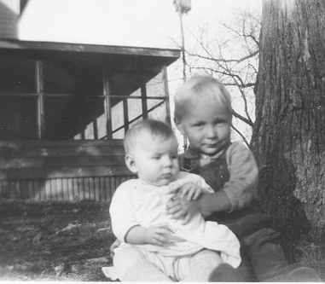

A very young Art and Irene Mielke pose in front of the Mielke home with the porch visible in the background. The porch was a favorite gathering spot on warm evenings.

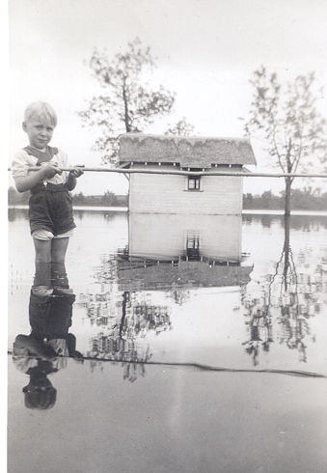

Art Mielke stands in water that came up onto the property after a major cloud burst. One of the resort's cabins and the opposite shore are in the background.

*article as originally printed in the Mouth of Lake Sarah October 2001

