Another History Lesson: Camp Ajawah at Lake Sarah

By Dolores Ullstrom

The following are passages from Charles B. Reif's account of his boyhood. He wrote this for Hennepin History. Charles Reif earned a doctorate in zoology at the University of Minnesota in 1941 and taught at Bucknell Junior College until 1982. Camp Ajawah was located, I believe, on The Klaer Brothers' Resort. The Jacobson home is located within the old campground boundaries. In future issues we'll have more excerpts to share.

"Camp Ajawah was the summer camp of Troop 33, which headquarters in the Westminster Presbyterian Church of Minneapolis. During the summer of 1923, the first season on Lake Sarah, Camp Ajawah began in history of providing scouting and camping experiences, one that continues today. In 1929 the camp was moved to Lake Linwood, north of Minneapolis. I spent seven summers at Linwood, but those first five seasons on Lake Sarah, west of Minneapolis, stand in my memory as the most wonderful of my life."

"One of the scouting activities was mapping, ... The 10 tents stood in a curving line atop a ridge. The flat area between that ridge and the lakeshore probably was lake bottom in postglacial times. Behind the ridge the ground sloped off gradually so that it was almost as low as the lakefront flats. An intermittent stream, which arose northeast of the tentline and passed under the railroad track through a culvert, flowed through the maple-basswood forest. The stream, which entered Lake Sarah outside the barbed-wire fence marking the camp's boundary, ran during spring breakups but was usually dry during the camping seasons. I discovered that it connected with the lake one time when I found, in a pool under the culvert, a four-inch northern pike, emerald green and almost translucent. A number of scouts passed their tests in bridge-building by erecting spans across that small stream in the woods.

"All the tents at Ajawah were standard army-surplus squad tents, each with a wooden floor raised a foot or more above ground. The first tent in line, at the southeastern end, was headquarters, the tenth tent, at the northwestern end, hindquarters. Although some of the more imaginative leaders named their tents, numbers more commonly designated which tent had won inspection, which was on KP, which was assigned on a particular day to clean the latrine, which were opponents in scheduled athletic events. Occasionally the scouts of two adjacent tents joined forces for some competition, although rivalry between tents was usually intense."

"One of the important gimmicks in the operation of Camp Ajawah at Lake Sarah was the point system. Campers could earn points for a variety of activities such as completing scouting advancement, nature study, swimming proficiency, woodcraft, reading, camp labor, and so forth. The specific posted list was long and challenging."

"Talking after 'Taps' was not condoned. After Kyle had gone down the line, stopping at each tent to say "Good night," we were supposed to keep quiet. Sometimes after 'Taps' we heard the roar of heavy trucks to the south of camp, especially on still evenings. Since this was during Prohibition we often speculated that those nocturnal trucks were driven by rum runners along the road that ran north and south through Loretto and one that ran east and west to the south of Lake Sarah."

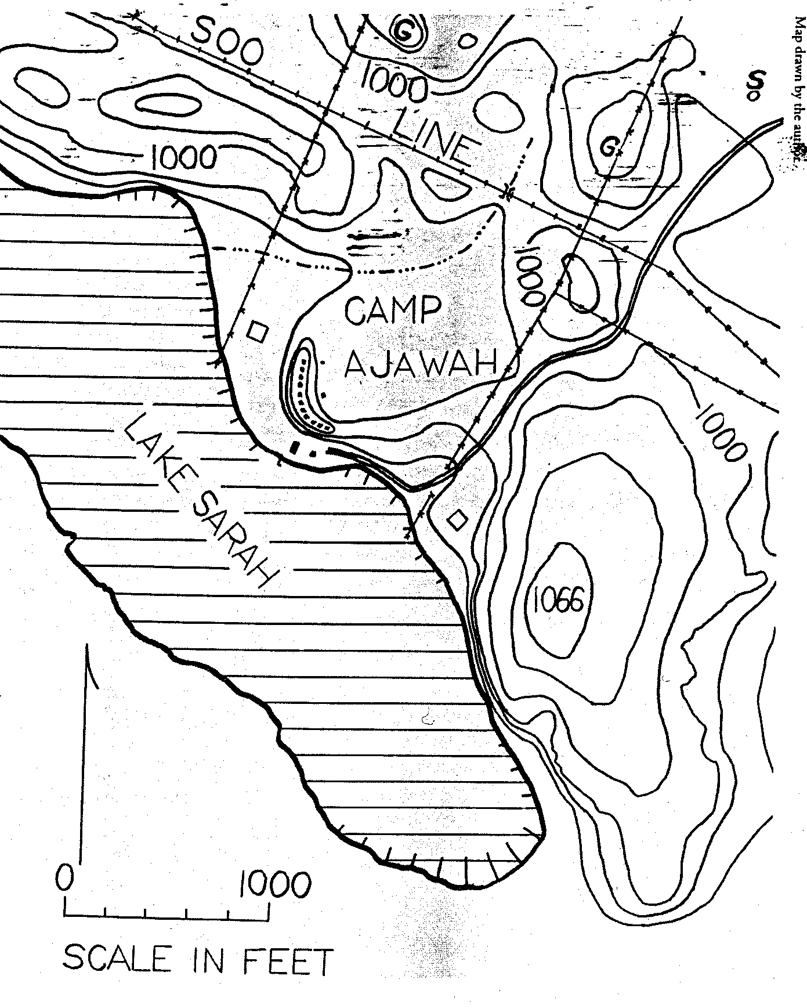

Camp Ajawah Map

Camp Ajawa website http://www.ajawah.org/

