Lake Sarah Area History
A Visit with Dorothy Jacobs: Historical Nuggets
By Dolores Ullstrom

Dorothy Jacobs (nee Snodgrass) lived for over fifty years in Loretto on the corner of Lorenz and St. John in a home that she and her husband Lawrence built. She is a widow now and lives in Hillcrest apartments. She has been slowed up a bit by a broken leg that is healing ever so slowly. I had the good fortune to share a few hours with her this past summer. Our conversation inevitably got around to local history. The following are a few facts/stories that she shared with me.

Photo: Dorothy Jacobs
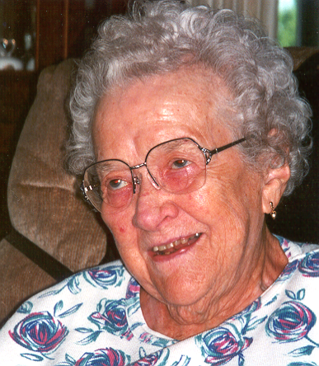

Dorothy was born in 1909 in a log house on a farm that is currently owned by her nephew. The farm is situated on Lake Charlotte near Greenwood, a Girl Scout camp. A sign on the property proudly proclaims the farm’s historical beginnings as the Snodgrass homestead. Dorothy was the youngest of 13 children. When Dorothy and her family moved out of the log house and into their new house, the log building became an ice house. Ice blocks were cut from Lake Charlotte, hauled to the log structure, and packed with saw dust for use during the hot months.

After graduating from eighth grade, Dorothy found work as a hired girl. Her first job was working for a family who had just had their tenth child. At 16 she moved to Minneapolis to live with a brother and to find work. For three years she left her Minneapolis job during the summer months to come back to Lake Sarah and work at the Lake Sarah Inn. She and her sisters Florence and Nettie worked there together during the 1920s, earning $7 per week for 7 days of work.

Every Sunday Mrs. Anderson, the Inn’s owner, made a delicious chicken dinner. She got up about 3 AM and started preparing dinner. About 100 people from the cities showed up each Sunday. Dessert was always chocolate cake. The hired girls helped prepare the chickens and vegetables. They also worked cleanup. A light meal was served in the evening. When everything was cleaned up after supper, the girls had the rest of the evening off.

During the ‘20s everyone worked hard, but people were very poor compared to today’s standards. The “good life” was lived by the few who were wealthy.

Dorothy’s sister Charlotte (Hohl) worked for a time as hired girl for the Florida family, owners of the historical house in Rockford now known as the Ames/Florida/Stock House.

In the early days, automobiles were driven in good weather only. During the winter months, roads were impassable and card were put up on blocks.

The Lake Sarah Dance Hall was located on the site of the Terry and Mark Holten home. The entrance was off Highway 55. Dances were held in the summer only because the building was unheated. Dorothy reports that it was the biggest social draw in the area. It was the most popular site of local wedding dances.

For many years there was, in the building that has been until recently called Fritz and Joyce’s, a restaurant known as Ma Widner’s. Ma Widner was a large woman who was, shall we say, a little rough around the edges. Ma was known for the high top leather boots she wore, her delicious fried chicken, and cooking for Loretto’s volunteer firemen. After every fire all the firemen were invited back to her restaurant for chicken dinner. Often she got up in the middle of the night to fix dinner so that it was ready when the firemen returned to town. The dinner was served at no cost to the firemen.

At one time Loretto had a creamery called Dutch Mill Dairy (because of the numerous Dutch farmers in the area?). Part of the brick building and smokestack are still visible. The dairy was known for its delicious ice cream. Before the creamery was built, farmers sent their cream to Minneapolis via train. After the creamery closed, the building was used by the plastics division of Tonka toys, which later moved to Spring Park.

Simon’s Hotel

Barbara Ebert (nee Simon) was the youngest of the Simon’s 13 children, seven of whom lived to adulthood. Many of her older siblings died in childhood when they became infected with whooping cough and chicken pox at the same time. Barbara was the only child left at home when her parents moved from their farm east of town into Loretto to the hotel which they had built. Barbara was often kept home from Saints Peter and Paul school to help with chores. She changed beds, waited on tables, and helped her mother prepare meals. She said her mother was a really good cook.

Photos: Simon’s Hotel
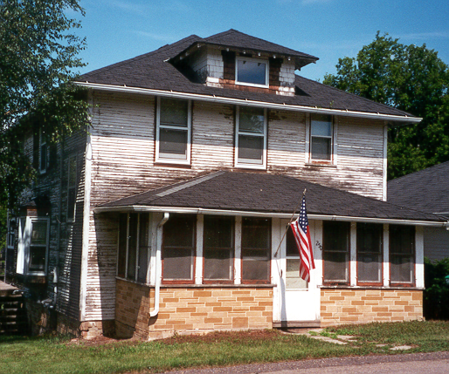

The upper floor of the hotel had six rooms. Many railroad employees, including the station master, stayed at the hotel. Salesmen traveling in the area or going through town on the train also stayed in the hotel. Mrs. Simon served her guests three meals a day. At one time there was a stable on the property. After her husband died, Mrs. Simon ran the hotel by herself. After she died the hotel was sold. At one time the hotel was made into a duplex.

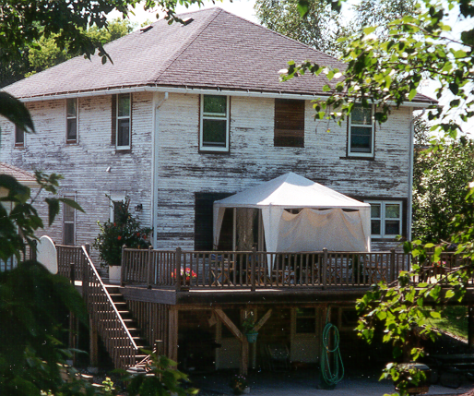

In 1966 Rick and Rosie Arens moved into one of the apartments. They bought the hotel in 1967 and sold it in 1974. The next owner, a family named Benson, returned it to a single family dwelling and sold it to Jim and Jan Marrs in 1978. The Marrs continue to live there and plan to remodel in the fall.

Thanks, Dorothy, for sharing your memories with LSIA members. Word has it that local history is a favorite topic with readers.

*This article originally printed in the Mouth of Lake Sarah newsletter published October 2000

