Lake Sarah Area History
Wally’s Resort: A Great Place to Visit!
By Dolores Ullstrom

Wally’s Resort was operating on the east basin of Lake Sarah when our family moved here in 1976. Our children used to ride their bikes to Wally’s to buy crème soda, but, except for knowing its name, Gene and I were almost oblivious to its existence. As a result of researching the resort’s history, I am experiencing some regrets. By not stopping in, we missed a bit of Americana that has disappeared, never to return.

Those who knew Wally Georges describe him as likeable and generous with a caring heart, always trying to make life better for his family. He had a respect for people, including his wife and family, that drew people to him. Louise, Wally’s wife and partner who now lives in Loretto, is a hard-working, independent minded woman who ran the resort and managed to raise their six children.

Photo: Louise Georges, who built Wally’s Resort with her husband Wally in 1956
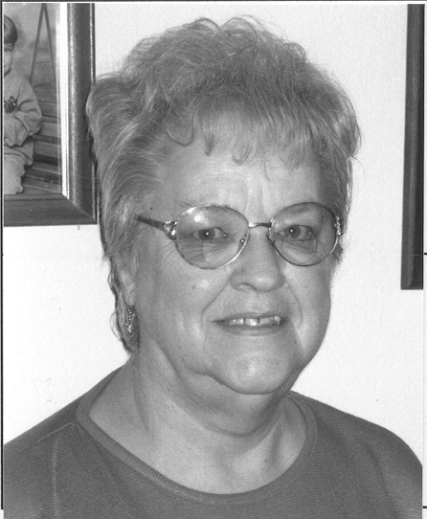

In preparation for writing this history, I interviewed Louise; Sue Ristau, daughter of Louise’s sister, Helen Bukowski; Jim Rau, who bought the resort from Louise; and Becky Jacobsen, who now owns the property with her husband, Kim. It was obvious after talking to all of them that Wally’s Resort was more than a commercial enterprise. It was a home, a place to celebrate with family, and the “Cheers” of its time.(continued Page 5)

(Continued: Wally’s Resort: A Great Place to Visit!)
Wally and Louise were married in 1945 at the end of WWII, when Wally completed his tour of duty with the Navy. Wally worked in construction with his brother Norman. While he and Louise were getting themselves established they lived in resort cabins in the area. After Roger, their first child, was born, the family sought a warmer house and spent the winter with Helen and Lambert Bukowski and their baby girl, Susan. Susan and Roger became best of friends.

Louise and Wally eventually lived on Lake Independence, managing a resort until that property was sold. The property is now the site of YMCA’s Camp Iduhapi. The Georges bought the resort’s ten fishing boats and set about finding a site for their own resort. On the Alfred Klaers farm they found what they were looking for. The land was part of the Klaers Brothers Resort and a former Boy Scout Camp. The City of Independence provided an access road to properties of five acres or more, so the Georges purchased five acres. When Wally’s was built in 1956, there were seven other resorts on Lake Sarah. They were mostly boat rental and camping type resorts, with a few cabins on some of them.

Photo: Wally and Louise Georges at Wally’s Resort about 1956
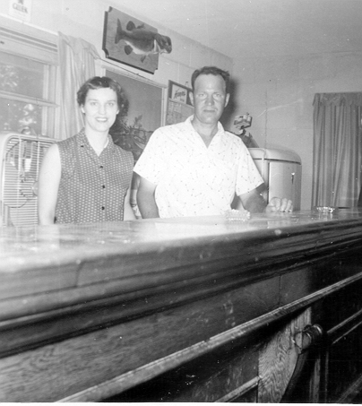

Susan Ristau says she spent a lot of time at Wally’s. She can remember the time when her mother went to the hospital to have a baby. Susan, being cared for by Wally and Louise, was homesick. She cried and cried. Wally, sad to see her so unhappy, picked her up and sat her upon his knee. They had a heart to heart talk. Wally promised Susan that she would always be welcome at the resort and have a place to swim and play. Susan says that was so like Wally. He had a winning way with people, even little people.

Wally was an industrious fellow. Besides his construction work, he kept animals on the property. The pole barn is still there along Sunset Lane. He raised pigs, cows, and chickens and for a few years had two pet raccoons. Louise, no slouch herself, was up early in the morning, ready for fishermen who arrived around sunup. Some would stay on the lake until dark. Louise was on duty until well after midnight, when the last of them left for home. Wally and Louise hosted an annual wild game dinner that drew in family, regular patrons, and neighbors. While most of the resort’s business was in summer, Wally kept a winter road open for ice fishermen.

The resort had a bar with a beer license. The resort later got a set-up license from the city, and Wally and Louise decided to add a dance floor. Dances were held on Sunday evenings, when musicians like Banjo Benny from Buffalo would come and play country western music. Susan recalls that her sister Nancy had her wedding reception there. Susan had her graduation party and a wedding shower there. The resort was also the site of many family picnics.

In his early 50s, Wally became sick. In 1979 he and Louise sold the resort and moved into a home they built a short distance away. Five months later in April of 1980, Wally died of cancer.

Jim Rau bought the resort and, after major remodeling, moved into the house. The dance floor is still intact, as is the large fireplace. The stucco exterior was given a facelift with cedar siding. A three-car garage and expansive decking were added. There are about 2500 square feet of living space on the first floor. The Benson family later lived in the house for several years.

Becky and Kim Jacobsen bought the house in August of 1992. It was the first house the realtor showed them and was not yet officially on the market. One foot on the property and Kim was sold. The realtor asked, “Don’t you want to see the house?” The Jacobsens have not done any structural change. They have changed the décor from hunting lodge to light and airy lake home. They continue to love the place and hope to remain there forever. “It’s a great place to raise a family,” says Becky. Recently Kim met one of Wally and Louise’s sons on the lake. The six Georges children all live in the area.

Wally’s Resort is gone, but fond memories continue for a lot of folks. Things change, but the need for community building remains constant. As a community, we appreciate the Jacobsens’ generosity in hosting the annual LSIA picnic. Laughter and good times can still be heard on the site of old Wally’s Resort.

*article as originally printed in the Mouth of Lake Sarah newsleter October 1999

