Jackie and Denny Johnston Leave Memories of Lake Sarah

By Jackie Johnston April 2, 2005

Dennis (Denny) Johnston first came to Lake Sarah as a young boy of fourteen. His parents, Marvin and Ethel Johnston bought a cabin on the Lake and Denny spent much of his youthful summer days fishing on the lake in the late ‘50’sa . That is when he wasn’t working at Shady Beach Resort. He worked for Milton (Mac) Makousky who with his wife Dorothy, owned the resort. His duties included cleaning out the fishing boats, mowing grass, fixing motors and general maintenance. He earned a whole $15 per week and worked six day a week. Monday was his day off. The area he had to mow included Shady Beach area, all the cabins which went as far as what is now Jorgensons and up the hill to So. Lake Sarah Drive, and the yard for Shady Beach Inn. He cleaned and maintained 36 boats and 3 pontoons. Prior to working at Shady Beach, Denny worked for summer for Bud Epple at Elm Beach Resort. Marvin Johnston built some of the flat bottom boats for Elm Beach Resort.

Denny’s father, Marvin, bought the bell from Shady Beach a year before Denny started working there when he was 15. It had been used by the Anderson’s when they owned the resort. The Johnston’s still own the bell. They have had it for sale for a couple of years but if no one buys it, it will grace a garden at their new home. (The bell has since been sold to Brad & Lisa Spencer)

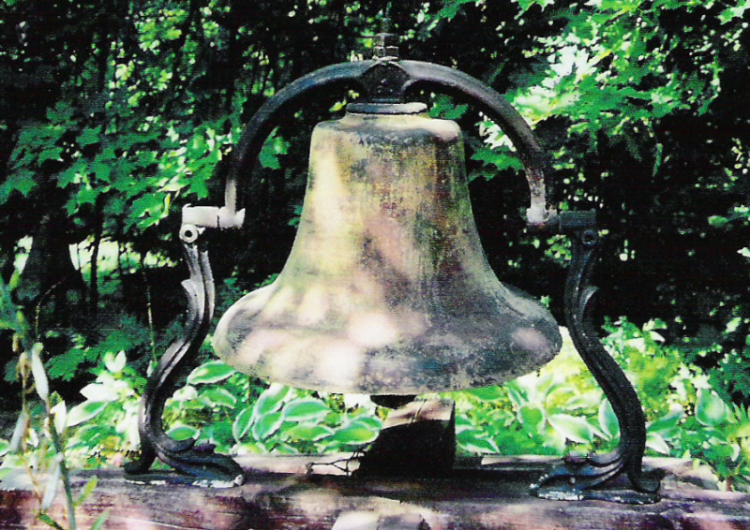

Denny remembers one very scary moment working at the resort. He set the emergency break on the truck when it was behind the house near the hill. He unloaded a heavy load of sweeping compound from the back of the truck and the emergency break let go. He jumped on the back of the truck and tried to climb in the window but the truck hit some tree roots and came to a jolting stop throwing Denny to the ground. The truck was rocking up on two wheels. He said he looked up at that truck balancing on two wheels and time stood still. It came back down on four wheels and he got back into the truck and drove it to Shady Beach. He told Mac about it and said he would never trust an emergency break again.

When he was 18, his parents rented out their home in Minneapolis and moved to their cabin. Denny drove to Edison High School in Minneapolis the last three weeks before his graduation in 1961.

In August of 1961, Denny and friend George Becker, went to New Germany to visit George’s grandmother. They attended a dance at the Young America pavilion where Denny met Jackie who was spending a couple of weeks with her friends the Weege’s of Hollywood township. They continued to see each other at the weekend dances and when George visited the Weege farm.

In the fall, Jackie returned to Montrose and Denny stopped by to ask her for a date. Denny made a lot of trips to Montrose and later to Waverly when Jackie and her family moved. Gas was only 29 cents per gallon but then Denny didn’t make much money either. Many of their dates were spent on Lake Sarah fishing or just watching a sunset from his red ’56 Ford.

Denny went to Dunwoody for a while but dropped out to work at Tennant Company. He started working there in March of 1962 and retired 35 years later.

Jackie and Denny became engaged in January of 1962. In June of 1963, Jackie went to work for the Makousky’s at Shady Beach Resort. She made $10 a week plus room and board and worked six days a week. She cleaned cabins, did dishes, stocked the coolers, cleaned floors and did lots of ironing on hot summer days, most of which were linens for the tables for Shady Beach Inn. She said her worse job was cleaning the grates from the grills in the cold lake. No chemicals were used to remove the burnt on grease. Just a lot of scrubbing with sand from the lake.

She also occasionally worked the banquets held at the Shady Beach Inn. She waited tables and did kitchen duty. That was after putting in a full workday at the resort. Her day began at 7:00 am and ended at 1:30 am. There was no overtime. It was all part of her $10 per week salary. Her last work date was Labor Day.

She moved to an apartment in Delano to plan her wedding. Jackie and Denny Johnston were married on October 26 in Minneapolis and their wedding reception was held at the Shady Beach Inn. The dance area was what is now the living room of the home that sits on that property today. It had a stone fireplace and beautiful wooden floors. There was wainscoting around the main room.

The area looked much different back then. When Denny started working at Shady Beach, it was just a small boathouse with lots of cabins. It was a room with fish tanks, a kitchen area and the bar area. When Jackie worked there, the dance area had not been built yet. But Jackie and Denny’s son Dennis (Bill) had his wedding dance at the resort in 1982. There were bands most weekends throughout the summer in the ‘80’s.

Shady Beach Inn, also called the Big House, was huge. It could be seen for miles as it sat at the top of a hill. It was one of the highest points in Hennepin County. Denny said he could see the whole Minneapolis skyline from its roof. It had an old stone foundation and porches on both lower and upper areas. It had gone through some changes and the big front porch was removed and an addition was put on in its place. Jackie once stayed over night in an upstairs room and remembers beautifully designed rooms with faded wallpaper. It must have been a gracious elegant building in its early days. In the late 60’s, Mac tore down most of the house to create a rambler where he and Dorothy planned to live in their retirement but Mac died in within a year and never finished the remodeling. Dorothy sold the house to Erikson’s. The families that have lived there since were Shultz, Emery, Emmer and now Freeman.

Lake Sarah was a well known fishing lake and people came from as far as Chicago to visit. According to Bud Epple of Elm Beach Resort, they would come by train and take one of the ferry’s to Shady Beach. When Bud was a kid, he used to clean the prop of one of the big excursion boats. The other was a big paddle wheeler which is said to have sunk east of Shady Beach Resort. Denny could not find any remains of it.

Where the train stopped is not known. There was a railroad line that went over the tip of Lake Sarah on what is now County Road 11. That was in 1860. But by 1879, the railroad was gone and the road that is now South Lake Sarah Drive was in place. The city map of 1914, shows a new railroad line on the north side of the lake. The Johnston’s were told by one long time resident years ago about a stage coach that used to go past Shady Beach Inn as well. One old map called it Delano Road. That was before County Road 11 was put in. It was considered a very popular resort at the time. The Johnston’s never heard when Shady Beach Inn was built. Denny had heard that at one time, there were 12 working resorts on Lake Sarah. The Johnston’s had an old brochure which they donated to the Western Hennepin County Pioneer Association that was from 1946. They made a copy before they donated it. It shows Breezy Hill Resort, Hillcrest Resort, Frederick’s Resort, Lake Sarah Pavillion, Elm Beach Resort and Shady Beach Resort. South Lake Sarah Drive was listed as Lake Sarah Road. Later, there was Beamish Resort and Wally Georges. The Johnston’s never heard where the others were that would make up the 12. That may have been just a rumor but it would be worth researching.

In its earliest days, Shady Beach was also a working farm with a barn. Denny remembers tearing out the foundation from the barn and he tore down the garage. The barn was north west of the Inn. The garage was insulated with old newspapers from before WWII. Denny remembers reading some of the ads and marveling at the low prices. The area along So. Lake Sarah Drive was all pasture with lots of trees.

The land also looked very different in 1963. The area from the Shady Beach Inn to Landgraf’s was all vacant pasture land. There was just one cabin between Denny’s parents cabin at 4620 So. Lake Sarah Drive and Shady Beach Inn.. In 1965, Mac Makousky, divided it up into lots and sold them for $2500 each.. His son Mike had first choice of the lots and he chose the lot where Nelson’s live and built the house. Denny was given second choice and he and Jackie picked their current site at 4590 and moved his parents cabin onto the lot in 1966 as his parents had built a new home. Jackie and Denny lived in that cabin until 1969 when they built their current home with the help of neighbor Oscar Anderson, his father, Marvin Johnston and Denny’s best friend Ron Wishnewski. Ron had bought one of the cabins at Shady Beach.

Jorgeson’s Park looked much different. There were large mounds called “hogs backs” that were in that area. There were two of them. There were also wetlands and tall grasses so it was not possible to walk the area because you would sink into the water and not be able to see it. Mac later leveled the area and tried to fill in the wetlands. It didn’t work. He dumped all that soil into the hole and it just kept sinking. It was finally tiled and made into a pond.

In the late fifties, the DNR seined the lake for carp and brought up several Northerns that were over 40 pounds and bass that were around 10 pounds. Bud Epple showed Denny pictures of the racks of walleyes they used to catch in Lake Sarah. That was before they all went out the outlet in the 20’s and couldn’t get back during the drought years.

Denny said that rumor was that Wally Georges used to pick out game fish from his minnows and put them into the lake and some of them were musky. Denny said that he tied into something in the narrows on five different occasions, that broke his new 50 pound line, broke his rod and put gashes in a minnow a half inch apart. He never caught what ever it was. He never saw it but it would validate the rumor that Wally had stocked musky in the lake. Many others reported breaking their lines as well.

When Jackie and Denny moved to Lake Sarah, there were very few houses on the lake. There were a lot of small cabins at the resorts and some privately owned but there was a lot of open land. There were five resorts in operation at that time. The lake was very clear even though the cattle would come down and walk around in the lake at Klaers Farm. One year 36 houses went up on the lake and the lake was full of foam and dead fish. Digging up that much dirt caused run off in the lake and formed silt that caused the foam and the killed the fish.

Denny and Jackie were charter members of the Lake Sarah Improvement Association and Denny’ mother, Ethel Johnston, was their first secretary. The organization was formed to protect the lake from environmental damage.

In 1977, Jackie sought a position on the Independence Planning Commission but was refused an interview. When she went to the council to find out why, she was told they already had a woman on the planning commission. She pointed out problems in the way the appointments were made and that there was no one on the council or the planning commission north of County Road 11. In the fall, she ran for the council and lost but the new mayor, Jerry Mevisson, appointed her to the Planning Commission to fill a vacancy. She served for three years as Vice President. It was during those three years, that the city adopted its Comprehensive Plan, Zoning Ordinances and Sub-Division Ordinances.

Jackie and Denny served on the Historical Commission from 1978 to 1982. During that time, there was a Heritage Day celebration at the City Hall in 1978 and an Old Fashioned Ice Cream Social in 1982. In 1979, they worked on a float for the parade that ended up on the front page of the Star Tribune and won first place for organizations for the parade. The float featured three men who had served in WWI. The next year, Denny portrayed Thomas Jefferson on the Independence Float. The float was “Independence Past and Present.” It won first place. Denny created a sign for the back of the float that was a painting of the Liberty Bell. That sign was used for many events in the city and became the symbol for the City of Independence.

Denny and Jackie were founders and officers of the Evergreen School Preservation Society in 1988. It was an effort to save the school as a historical site. They helped to organize an all school reunion even though they did not attend that school. The school was later returned to the Delano School District.

Jackie and Denny were also charter members of Preserve Green Acres. It was an organization formed to stop the siting of landfills in this area. It started as a 2,500 acre landfill in western Independence but was changed to five landfills throughout western Hennepin County. Jackie served as Public Relations Director for the first three years. The goal was to encourage recycling and resource recovery in Hennepin County. It was to attempt to eliminate landfills, which leak and cause environmental damage. Preserve Green Acres also lobbied for the 1980 Agricultural Preservation Act, which helped farmers stay on their farms even though there was development all around them. It was part of keeping open spaces and preserving farmland for the city. Preserve Green Acres lasted 13 years and then disbanded because it had achieved its goals when Hennepin County and all the cities in the area went to recycling and the NSP Resource Recover plant was built. The last landfill in Hennepin County was closed in Medina. Legislation was passed to create zones for garbage to ensure a steady stream of garbage for the NSP plant so it would provide steady electricity. Jackie and Denny were part of the demonstrations that were done to raise public awareness. Denny dressed as the grim reaper for the Delano 4th of July parade and at a rally at the Hennepin County government center, complete with sickle in hand and fake rat in his pocket. The Star Tribune published his photo when they covered the story.

Jackie ran for the State Senate in 1992 and lost. The race lasted a year and shaped her life by bringing in new friends and new experiences as well as being very educational.

Jackie served on the board of Operation Roundup for Wright Hennepin Electric from 1994 to 2005. She was Vice Chair for a year and a half and then Chair for the remainder of the time. When she resigned, she was the last of the original members to leave the board. She said “This was the most emotionally rewarding experience of my life.” The work that the charitable trust does to the communities in the service territory is enormous. As of 2005, Operation Roundup gave $1.4 million dollars in grants. That is done with just a few pennies each month on our electric bills.

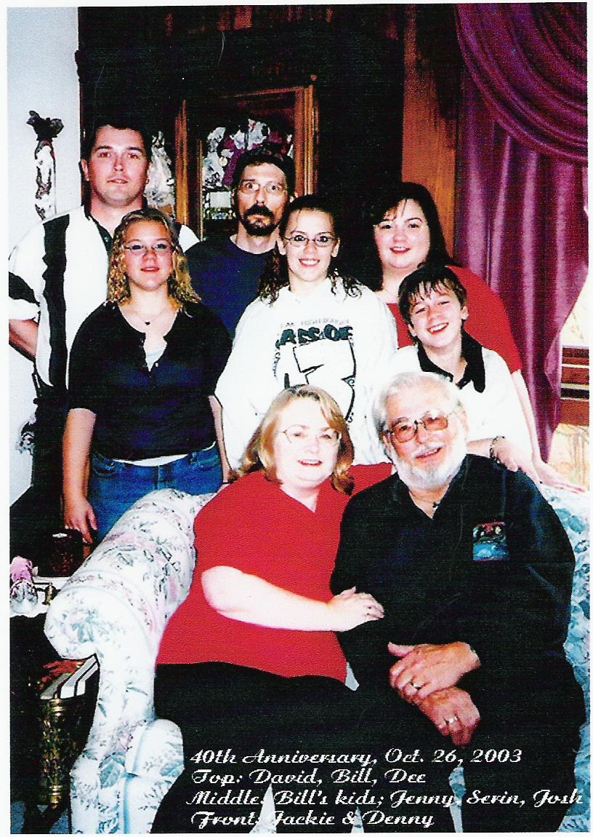
The Johnston’s have three children, Dennis Jr. (also known as Bill or DJ), David and Dee. David lives in Minnetonka, and Dee and Bill live in Maple Plain. All three children graduated from Delano High School. They also enjoyed many family events at their home with their grandchildren, Serinity, Jennifer and Joshua. The Johnston children have many memories of their own about growing up on Lake Sarah. They used to slide down Shady Beach Drive on icy days with the other neighborhood children. They swam at the lake and Dee had her 16th Birthday Party at Shady Beach Resort.

One incident that was not so pleasant to remember was when Bill Johnston was shot by the stepson of the owner of Shady Beach. Bill was 15 and a friend of the boy. The boy who shot him was a troubled youth who eventually got the help he needed. Bill still has the bullet in his back.

That day, the police arrived within five minutes of the call. There were 14 squad cars in the neighborhood. The boy surrendered peacefully. He was never able to tell Bill why he did what he did. It was a frightening thing to have happen in a quiet neighborhood. It was odd to see it on the evening news. It was a difficult time for the Johnston family.

One pleasant memory is of the day a wild Canadian goose followed Dee home from Shady Beach and decided it was going to live in the neighborhood. They called it Bruce the Goose. It was threatened a lot by dogs so Jackie and Denny tried to get the park to take it. They said they couldn’t because it had become too domesticated. So they tried releasing it at Lake Rebecca. They would take it to the lake and run back to the car. By the time they got to the car, the goose was sitting in the back seat. This happened three times. They did find a home for it on the Bob Pool farm. Bob and his family cared for a large number of birds and Bruce the Goose fit in just fine.

When the children were in grade school, a friend of the Johnstons had accidently shot a great horned owl while out hunting. They brought the injured bird back to the house. The Johnstons called the DNR to see what could be done but there was no raptor center in those days. So Denny tethered the bird and made a perch for it in the living room. It was a huge bird and the cats and dog did not bother it. They called it Bubo for bubo virginias, the latin name for a great horned owl. It was also sometimes called a cat owl partly because they look like a cat in silouette and partly because they hiss. Denny donned large gloves to feed the owl raw hamburger. He would also take the bird for walks to get fresh air. The owl lived with them until his wing was completely healed and then he was released. He lived in the area for many years and they could see him flying over the woods on Gallager’s farm.

Jackie and Denny were involved in DFL politics and had hosted many events in their homes. Many of their guests went on to serve in high office. Guests like Skip Humphrey, Mike Hatch and Mark Dayton.

Jackie also served as Secretary for St. Paul’s United Church of Christ in Delano.

Both Jackie and Dennis served on the Advisory Committee for the Delano Area Senior Center for two years. Jackie designed the brochure to help raise money for the new Senior Center. The new Senior Center is located at the City Hall in Delano. They did this in memory of Denny’s father, Marvin who was very active in the center and was recognized as a volunteer.

The Johnston’s are involved in the Scottish community and Denny is the State Commissioner for Clan Johnston in America. Jackie is the newsletter editor and is on the national council for CJA. They are members of the St. Andrew’s Society, and the Minnesota Coalition of Scottish Clans. Jackie is working on a book about Scots in Minnesota.

“We will miss our friends and neighbors and we will treasure all our memories” said Jackie Johnston.

The Johnston’s donated a book on the activities in Independence to the Independence Historical Society as well as a video of the All School Reunion for Evergreen Grove School. If you haven’t visited the Independence Historical Society, it is worth a visit. The Johnston’s donated items because there wasn’t much there on the Lake Sarah area.

