LAKE SARAH PAVILION’S
“POP CORN GIRLS”
Growing up at Lake Sarah and at the Mitchell Farm had many benefits, but it was a lot of work for the “Mitchell Girls.

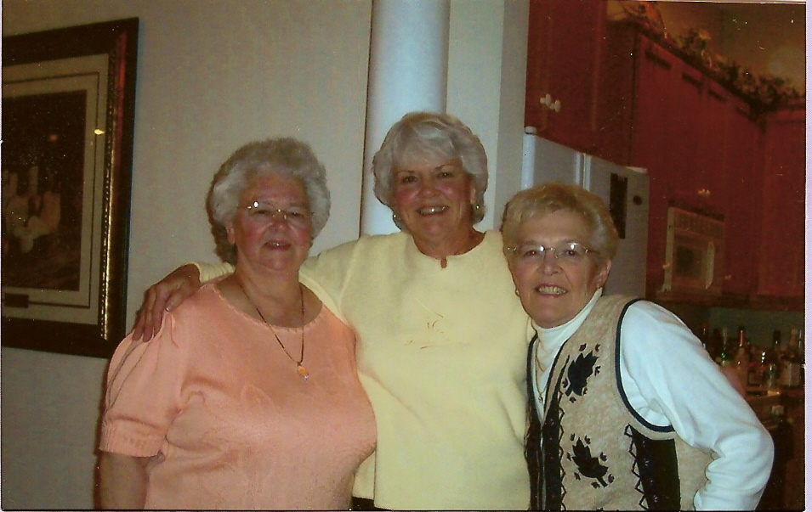
BETSY CAROL MARGIE

Betsy was the first to be recruited to helping on the Mitchell Farm. Before the dance hall was built she sold cans of angleworms for ten cents, to the people that her parents rented boats to. There had been the Mitchell Resort with 5 cabins and 10 boats. At the same time her parents farmed the 84 acres, that Sydney Mitchell had moved to when he was 9 years old. At night Sydney would play the fiddle and banjo at different barn dances, three to four times a week in the season.
In 1931 the Mitchell’s decided to build a 50’ x 100’ dance hall, called the Lake Sarah Pavilion, up on the hill of their farm.
The Pavilion had a Maple dance floor and shutters that opened to the lake, which was needed for the breeze; (there wasn’t any air conditioning), but there WEREN”T any screens. The Pavilion was opened Easter, 1932 and was sold and closed Halloween, 1964. Every year it opened at Easter and stayed open until Halloween, when it was closed for winter.
There are invoices for all the materials, that went into building the dance hall. IE.)

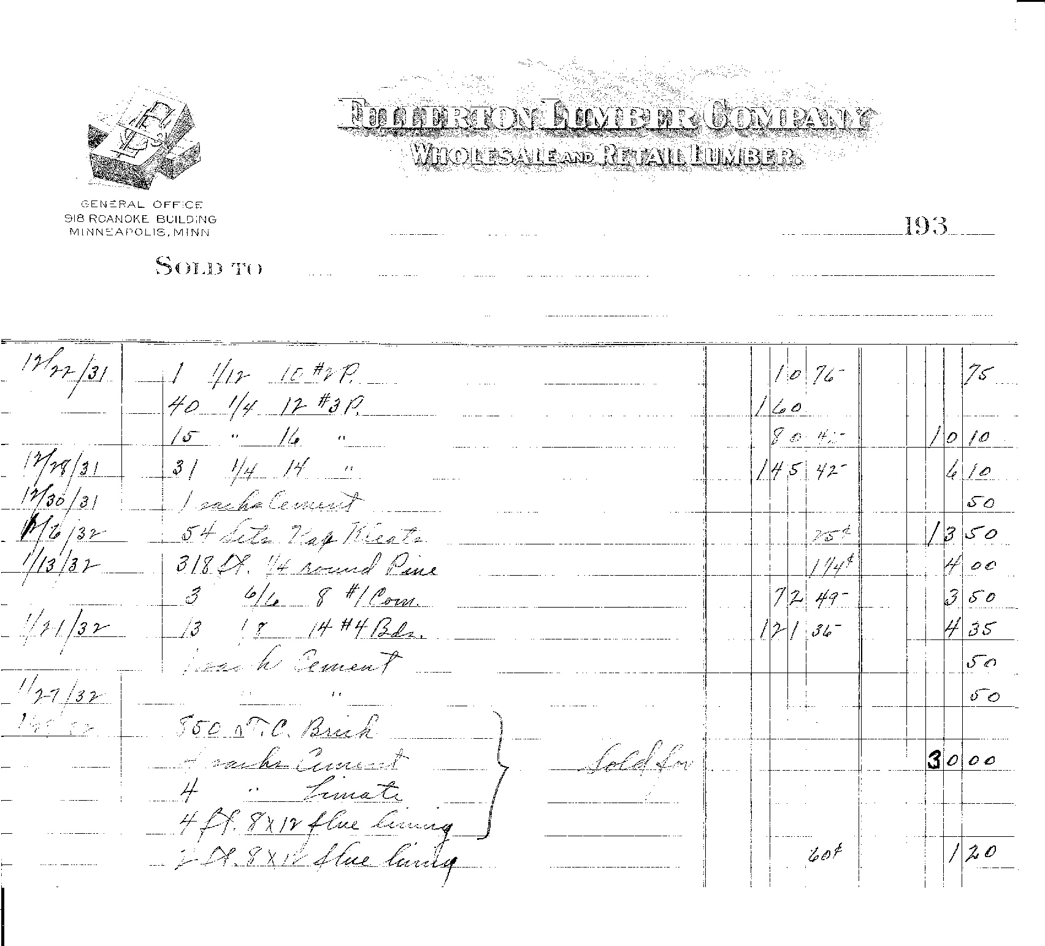

There were other Dance Halls in the area. One was in Loretto, just South of the railroad. It was built before the Lake Sarah Pavilion. Another one was at Reinkings, West of the Mitchell farm on the North side of Lake Sarah. Reinkings had a Gazebo that sold pop, candy, ice cream cones (that was Margie’s favorite) and the great fireworks! Between Mitchell’s place and Reinkings Resort was the train depot. Sometimes the train would stop four times a day, if necessary. Sydney Mitchell said he had seen as many as 50 or more people get off the train on a Saturday evening.
Loretto Dance Hall 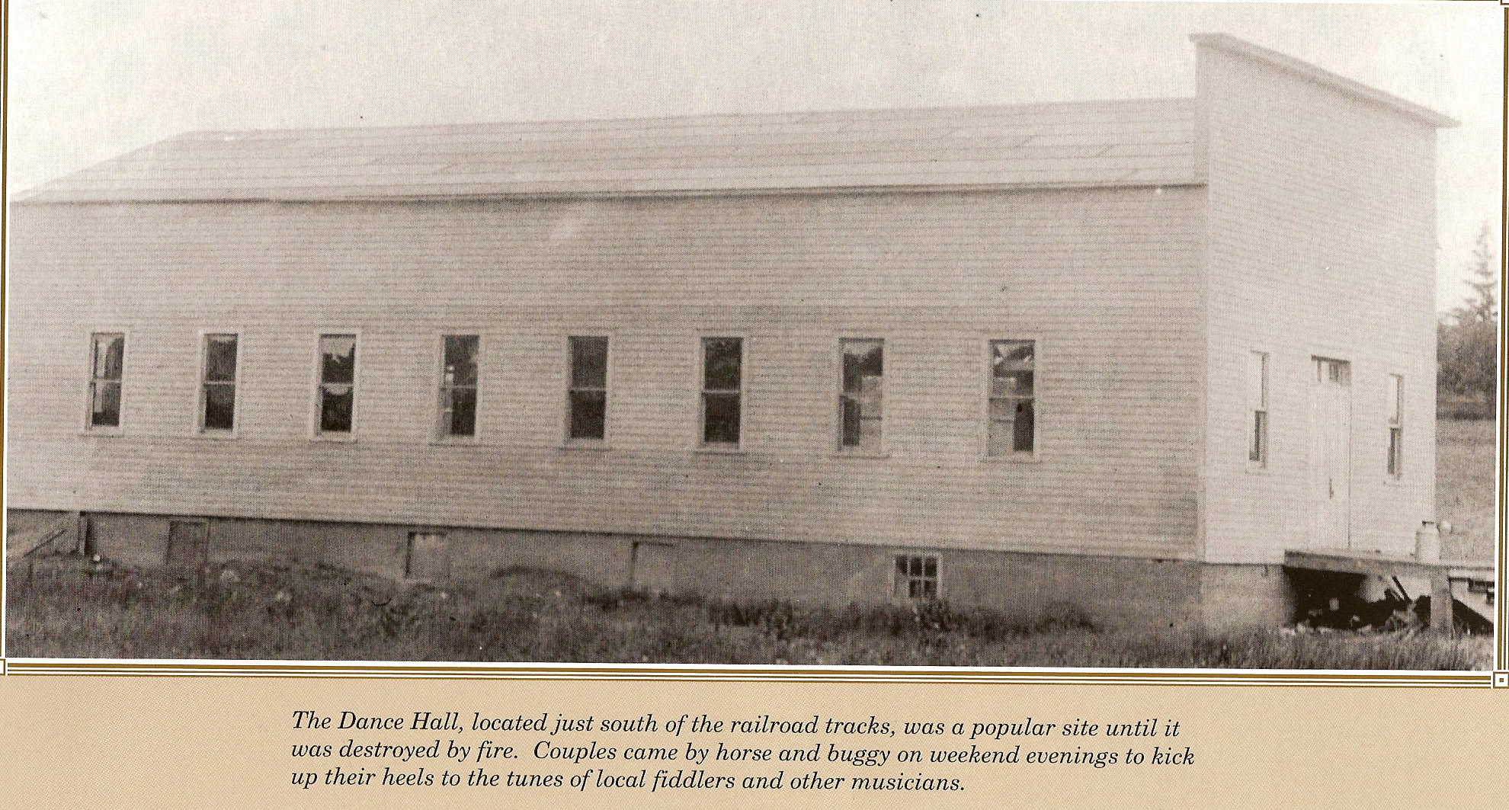

Once the Lake Sarah Pavilion opened. The first official Pop Corn Popper and seller, was Sydney Mitchell Jr. (Sonny). Three years later Betsy’s job description increased. Now she would sell popcorn that she made by hand besides selling fishing worms.
She was the first “Pop Corn Girl”, at 10 years old. She sold ten cent bags of approx. 2 cups of popcorn. After the cost for making it and 7 years later, she had saved $900 and loaned it all to her future husband, Lloyd Vergin, for a milk route. This adventure proved to be a successful one, and so did their marriage.
Betsy passed this job on to her two younger sisters, Carol and Marge. They also had the job of cleaning up the dance hall and their Uncle Ben had told them they could keep all the change they swept up off the floor. They didn’t know until years later that he would sprinkle change on the floor for them to find. When they took over the “Pop Corn Girl” job, modern times had arrived and they had a popcorn popper. The popcorn still had to be watched and Uncle Ben would check on it ever so often. He wouldn’t be very happy when he’d catch Margie out dancing with a cute fella and not doing her job because the popcorn would be burnt and then they’d have to redo it and that would come out of their profits. . Carol retired her title after 6 years to marry Jerry McCann. She used the money she had saved to buy furniture. Now Margie was a solo “PopCorn Girl”, after 6 more years she retired and had saved enough for a down payment on their first home as she became Mrs. Jerry Klaers.
Ben Mitchell, was the Dance Hall proprietor, he hired the bands and sold the dance hall tickets. Some times as many as 700 tickets would be sold for a dance. Lloyd Vergin was the hand stamper and some nights there were a lot of hands to stamp.
There is a story that several times Sydney would tap a keg and never shut it off until it was empty. A glass of 6 oz. beer was ten cents, and as fast as Syd could pour, Alex and Agnes Schumacher and Otto and Della Arens would sell them, along with fifteen cents set ups, pop and Laura’s (Mitchell) famous hamburger’s with onions.
There were a lot of name bands that played and here is an example of a line up for a few weeks.

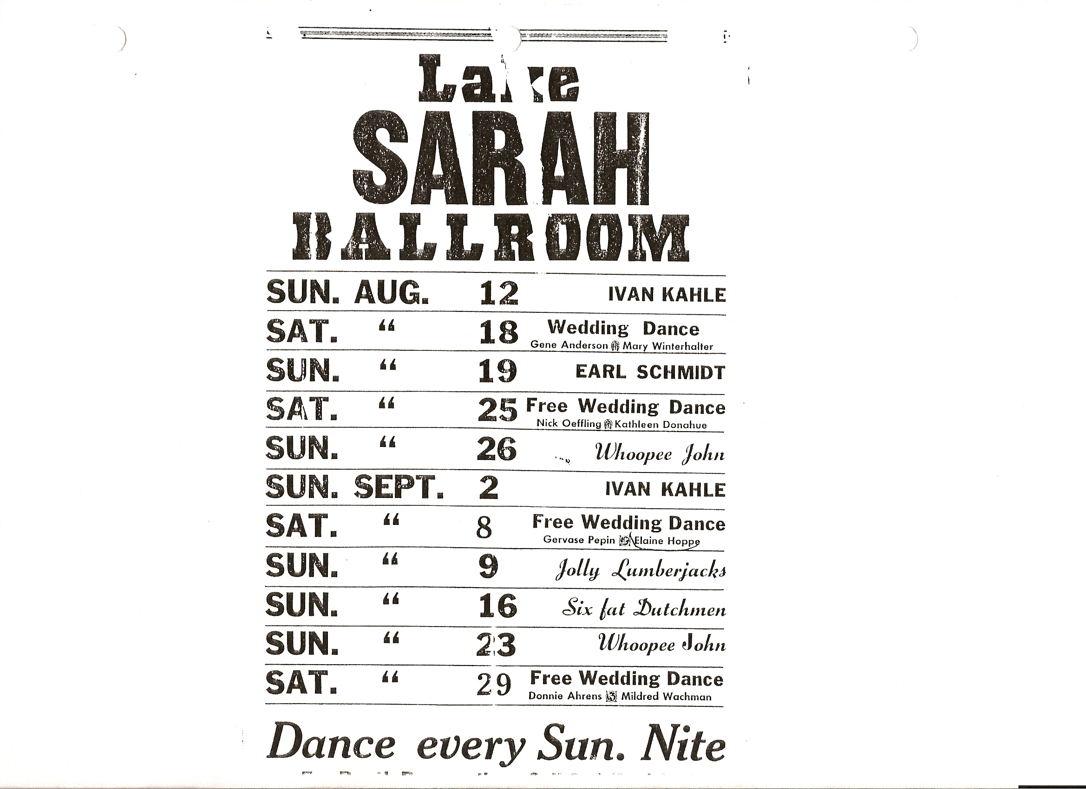

During the dances, there were security people to help out and they were Delbert Loeffler, Glenn Conzet, Leo Leuer and Ted Reimer.
The list of the resorts on the lake, as we know them. Starting on the far West end, North side: Herman Mielke – Breezy Hill Resort, Ivan Dorans – Hillcrest Resort, Reinking, Maple Beach, Lake Sarah Train Depot, Lyle Fredrickson’s Resort, Mitchell’s Resort – Lake Sarah Pavilion, Wally’s Resort. On the far West end on the South side: Epple’s Elm Beach Resort and then Shady Beach Resort at the channel. (The last working resort in Hennepin County before it closed).
There aren’t many pictures of the Lake Sarah Pavilion, but here is one with Carol as a small girl.

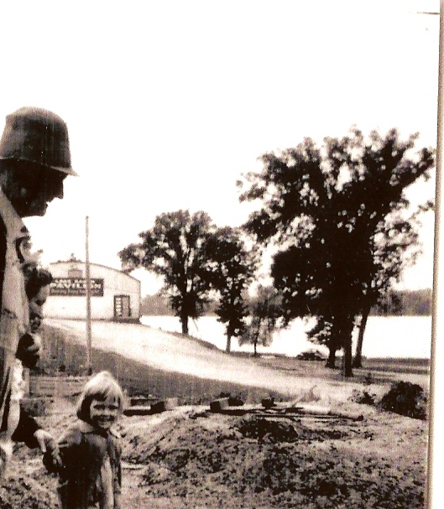
1932 thru 1964
Lake Sarah is in the background, or as it was once called, Lake Union.
After 32 years of business and 2 maple dance floors, The LAKE SARAH PAVILION closed on Halloween, 1964. It was sold and taken down board by board.
There are many residents that live in the area that can tell you stories about going dancing there, having their wedding receptions, or other great memories.
Thank you “Pop Corn Girls” (Betsy, Carol and Margie), for sharing your memories and time with me. For me, it was a very enjoyable morning. Kathy Hahn

