SPECIAL USE PERMIT
Three Rivers Park District
Natural Resources Management
12616 County Road 9
Plymouth, MN 55441-1248
Phone: 763-694-7840 – Meryl

Joe Slavec
Scott Walsh
Joe Baker
Mike Peterson
Brad Spencer
Lake Sarah Regional Park Neighbors

Permit for use of |  |  |  |  | Lake Sarah Regional Park |  |  |  | from | May 17, 2010 – May 31, 2010
Area in park to be used |  |  |  |  |  | Permission to be off trail to remove beaver dam on the outflow from Lake Sarah and to use a 4-wheeler ONCE ONLY to remove a large log from the site
Telephone
Time arrive |  | am |  |  |  |  | Time depart | pm | Number in Party |  | Up to ten
Purpose of visit |  |  |  | Removal of beaver dam – removal of large log with 4-wheeler
Fee | None |  |  |  |  |  | Condition/Equipment |  | Will bring own equipment

 | COMMENTS:
This permit must be carried while in the park and made available to park personnel upon request. For assistance contact park staff. Please read enclosed guidelines prior to your visit.
 | Carry this permit with you.
 | DATE: | May 17, 2010

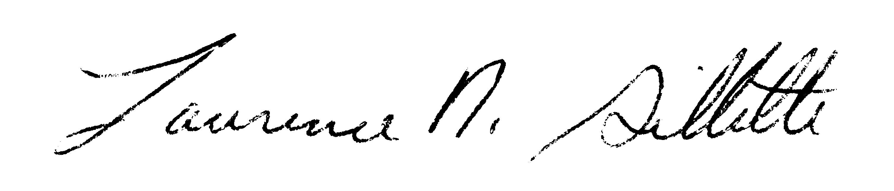 | larry gillette – senior manager of wildlife
Signature | Name & Title

violations of park ordinances are misdemeanors and can result in revocation of permit or arrest. violations of this permit and park guidelines may result in additional fees or fines. permit holder responsible for ordinance violation and damage to park property.

Cc: Public Safety, Lake Sarah Maintenance Staff, Tom Vetsch

